EU KA 203 PROMOTING ENTREPRENEURSHIP THROUGH CREATIVITY IN EDUCATION PROJECT
Introduction
Entrepreneurship, commonly defined as the process of creating shared value for business and society, is a dynamic force in a rapidly changing world. It thrives on a unique combination of public and private resources and capabilities to develop and exploit economic, social cultural and environmental opportunities. One of the key drivers of entrepreneurship is creativity, an innate or learned capacity to generate and recognize innovative ideas, alternatives and possibilities.
Defining Entrepreneurship and Creativity
This project starts by providing a comprehensive definition of entrepreneurship. It presents entrepreneurship as the art of creating value by skillfully blending public and private resources to seize opportunities in a changing environment. Entrepreneurship education, an integral part of this endeavor, aims to equip students with the knowledge, skills and motivation necessary to achieve entrepreneurial success in different contexts.
Creativity, another critical element of this project, is defined as the ability to generate or recognize ideas, alternatives or possibilities that can be applied in problem solving, communication and entertainment. It is emphasized that creativity is a matter of recognizing and developing innate abilities which should be nurtured and encouraged among students.
The Entrepreneur as a Driver of Creativity
The project also reinforces the symbiotic relationship between entrepreneurship and creativity. Entrepreneurs are portrayed as catalysts for creativity and are likened to astute investors in translating ideas into innovations. Just as entrepreneurs identify opportunities and take calculated risks to realize their vision, creative thinkers invest in ideas and possibilities to enrich their lives and contribute to society.
Project Goals
The main objective of this ambitious project is to develop entrepreneurial skills by incorporating creativity into education. This goal will be achieved through a multi-pronged approach, including the development of ICT-based educational materials and an entrepreneurship curriculum, the organization of Intellectual Property (IP) programs for students and teacher training programs for educators, and the conduct of research initiatives to measure students' entrepreneurial skills.
Target Audience and Activities
The project casts a wide net, engaging various stakeholders in the education and training community. The target audience of the project includes university students, teachers, teacher trainers, school principals, educational leaders and academics. To achieve its objectives, the project covers a variety of activities such as academic research, IP programs including lectures, workshops and case studies, curriculum development from high school to postgraduate levels, and the creation of ICT materials.
Dissemination and International Cooperation
The project attaches great importance to sharing its findings and results. In this context, the project website was established in the first phase and the activities were shared through this website (www.beyondthelimitsproject.sakarya.edu.tr). Therefore, the intended widespread impact will be achieved through local media outlets, websites, social media channels and academic publications. Conferences will be organized in Spain and Portugal to encourage global cooperation and keynote speakers from various countries will be invited to reach an international dimension.
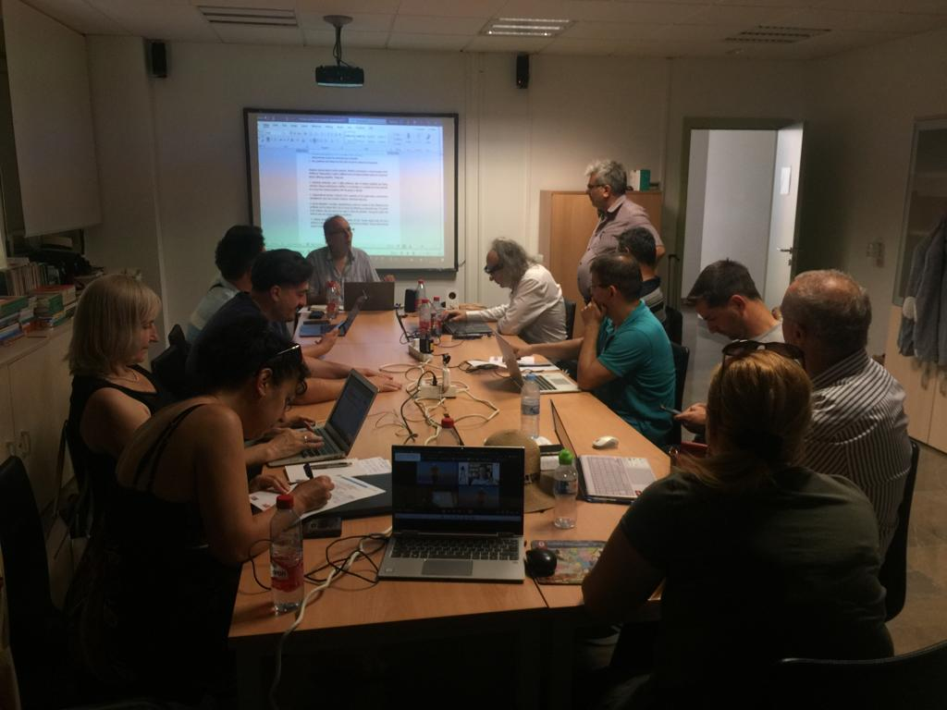
Picture 1. A Frame from the 1st Project Meeting at the University of Granada
Again, in order to increase the national and international impact of their activities, each partner is increasing their dissemination efforts by publishing news on their university websites and local media. In addition, project activities will be disseminated through social media accounts such as Twitter (https://twitter.com/beyondt29077346), Instagram and Facebook.
Academic Contribution and Impact
An admirable aspect of the project is its commitment to enriching the academic literature. It aims to publish articles and academic studies that explore the intersection of entrepreneurship and creativity in education. Within this aim, it is essential to foster creativity, critical thinking, problem solving abilities and leadership skills by providing rich and diverse contexts for students to acquire, develop and apply knowledge, understanding and skills.
It is proposed that by taking an innovative approach to promoting entrepreneurship through creativity in education, this project opens a threshold that may transform the field of entrepreneurship education. By targeting a wide range of stakeholders, relying on international collaboration and emphasizing the importance of creativity, this project can contribute to adapting to the evolving demands of a rapidly changing world. On the other hand, the project not only contributes to the academic literature, but also aims to empower individuals with the necessary skills and mindset to succeed as entrepreneurs and leaders in an ever-evolving global environment. Therefore, thanks to this project, the future of entrepreneurship education looks brighter than ever.
Coordination and Partnerships
Sakarya University, a non-profit public institution with a significant student population and a strong emphasis on ICT-based education, stands out as a leading institution in Turkey and Europe. With a rich history of organizing social projects, conferences and seminars, the university has become a center of academic excellence and technological superiority. The University's commitment to fostering creativity and entrepreneurship in education is highlighted by its ISO 2002 Quality Certification, its pioneering role in the development of quality management processes using the EFQM model, and its receipt of the Continuum of Excellence Award in Turkey. Other institutions partnered within the scope of this project, which was realized in line with this quality philosophy, are listed below.
- Agora University of Oradea-Romania
- Centro Studi Cultura Sviluppo Associazone-Italy
- De Montfort University- England
- University of Coimbra -Portugal
- University of Granada- Spain
- University of Liepaja Latvia
- University of Padova- Italy
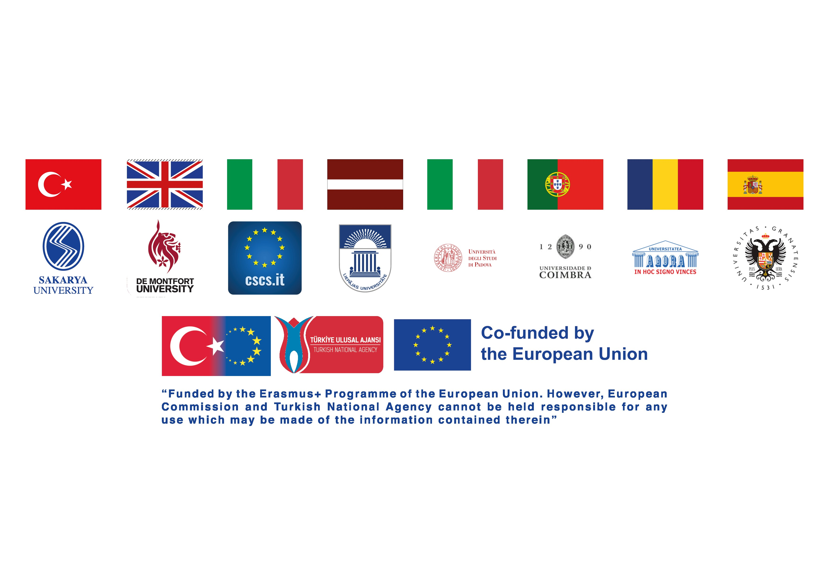

Scientific Activities
Teacher training programs, speeches and meetings in international communities, international conferences held in 2022 and 2023 can be shown as prominent events and activities.
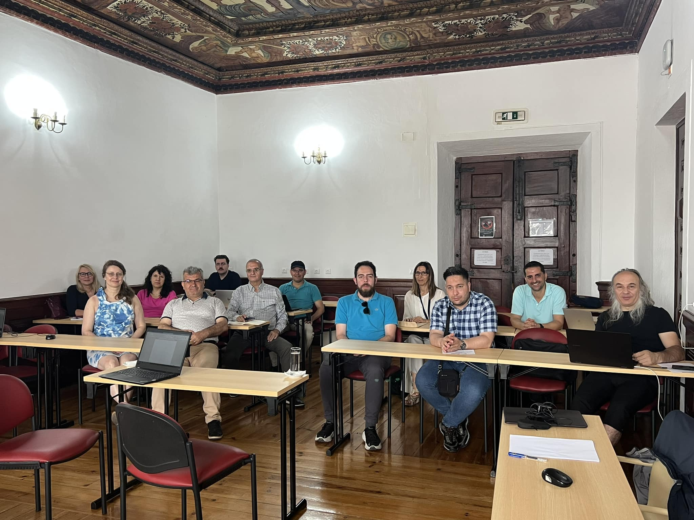Picture 2. A Frame from the 2nd Project Meeting at the University of Coimbra
The aforementioned activities were carried out in face-to-face as well as online environments. In addition, people with expertise in various fields were involved in the process from the initial creation of the project to its effective functioning. When evaluated in this context, the process, in which various outputs and products were obtained, can set a precedent for future projects and similar studies. Therefore, it can be argued that the project, which addresses a wide audience, has achieved the widespread impact that was initially intended.
On the other hand, thanks to ICLEL 2022 (University of Granada) and ICLEL 2023 (University of Coimbra), which were organized as dissemination activities during the project process, researchers who prepare papers on "Creativity and Entrepreneurship in Education" will be able to participate free of charge and their abstracts and full-text papers will be published with ISBN numbers, thus contributing to both their academic development and the educational community.

Outputs and Products
1. Need Analysis Book: It can be argued that the most significant output and product of the project is the "Need Analysis" book. This study, whose main focus is the creativity and entrepreneurship skills of university and high school students attending a higher education institution in the partner countries, has also become a study in which the barriers to creativity and entrepreneurship skills in the education system are measured and necessary solutions are presented. Within the scope of Need Analysis, based on the permission obtained from Sakarya University Ethics Committee, ENRO_COM Scale and Kaufman's Creativity Skill Level in Every Field Scale were applied to determine the entrepreneurship and creativity levels of students in all countries. A Global Report on the results of the applied research and the entrepreneurship and creativity levels of students around the world was prepared and ISBN number was taken, prepared under the leadership of the Portuguese University of Coimbra team and published publicly on the link http://www.beyondthelimitsproject.sakarya.edu.tr/need-analysis.html.
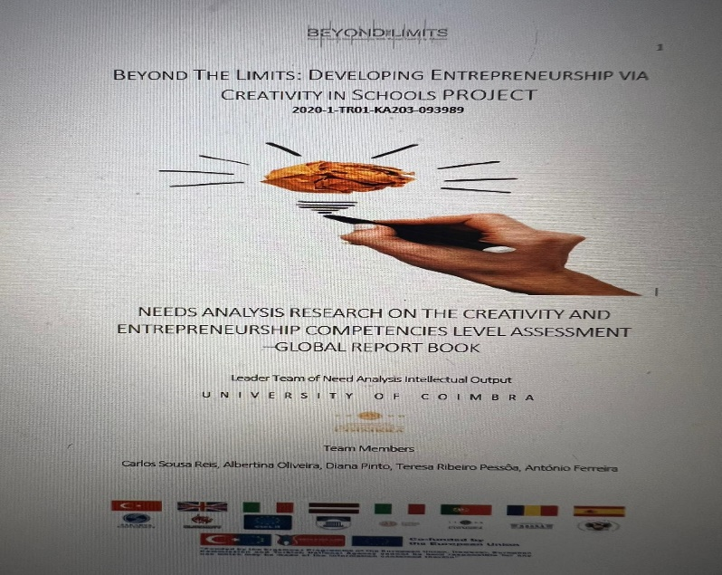
Picture 3. Need Analysis Report Book Cover Related to Entrepreneurship and Creativity
2.Online Education Platform and Online Videos: On the other hand, another valuable product created in the process is the Online Education Course Platform, Materials and Films. The main objective of this output was to create a comprehensive and high-quality ICT platform and materials on creativity and entrepreneurship to be used to enhance the creativity and entrepreneurship skills of students and young people at different levels. These created and recorded videos are publicly available on the website.
Resim 4. Girişimcilik ve Yaratıcılık ile İlişkili Hazırlanan Videolar
http://www.beyondthelimitsproject.sakarya.edu.tr/course-movies.html

3.Intensive Training Programs (For Teachers and Students): In this context, 2 student trainings were organized first at Sakarya University in January 2021 and then at Liepaja University in 2022, and teacher trainings were organized at Sakarya University. In each training program, 180 participants, including approximately 60 participants consisting of students and teachers, actively participated in the online and face-to-face activity parts and all participants were certified with the signature of the rector. It can be accessed from the links below:
http://www.beyondthelimitsproject.sakarya.edu.tr/ip-programmes.html
http://www.beyondthelimitsproject.sakarya.edu.tr/teacher-training-program.html

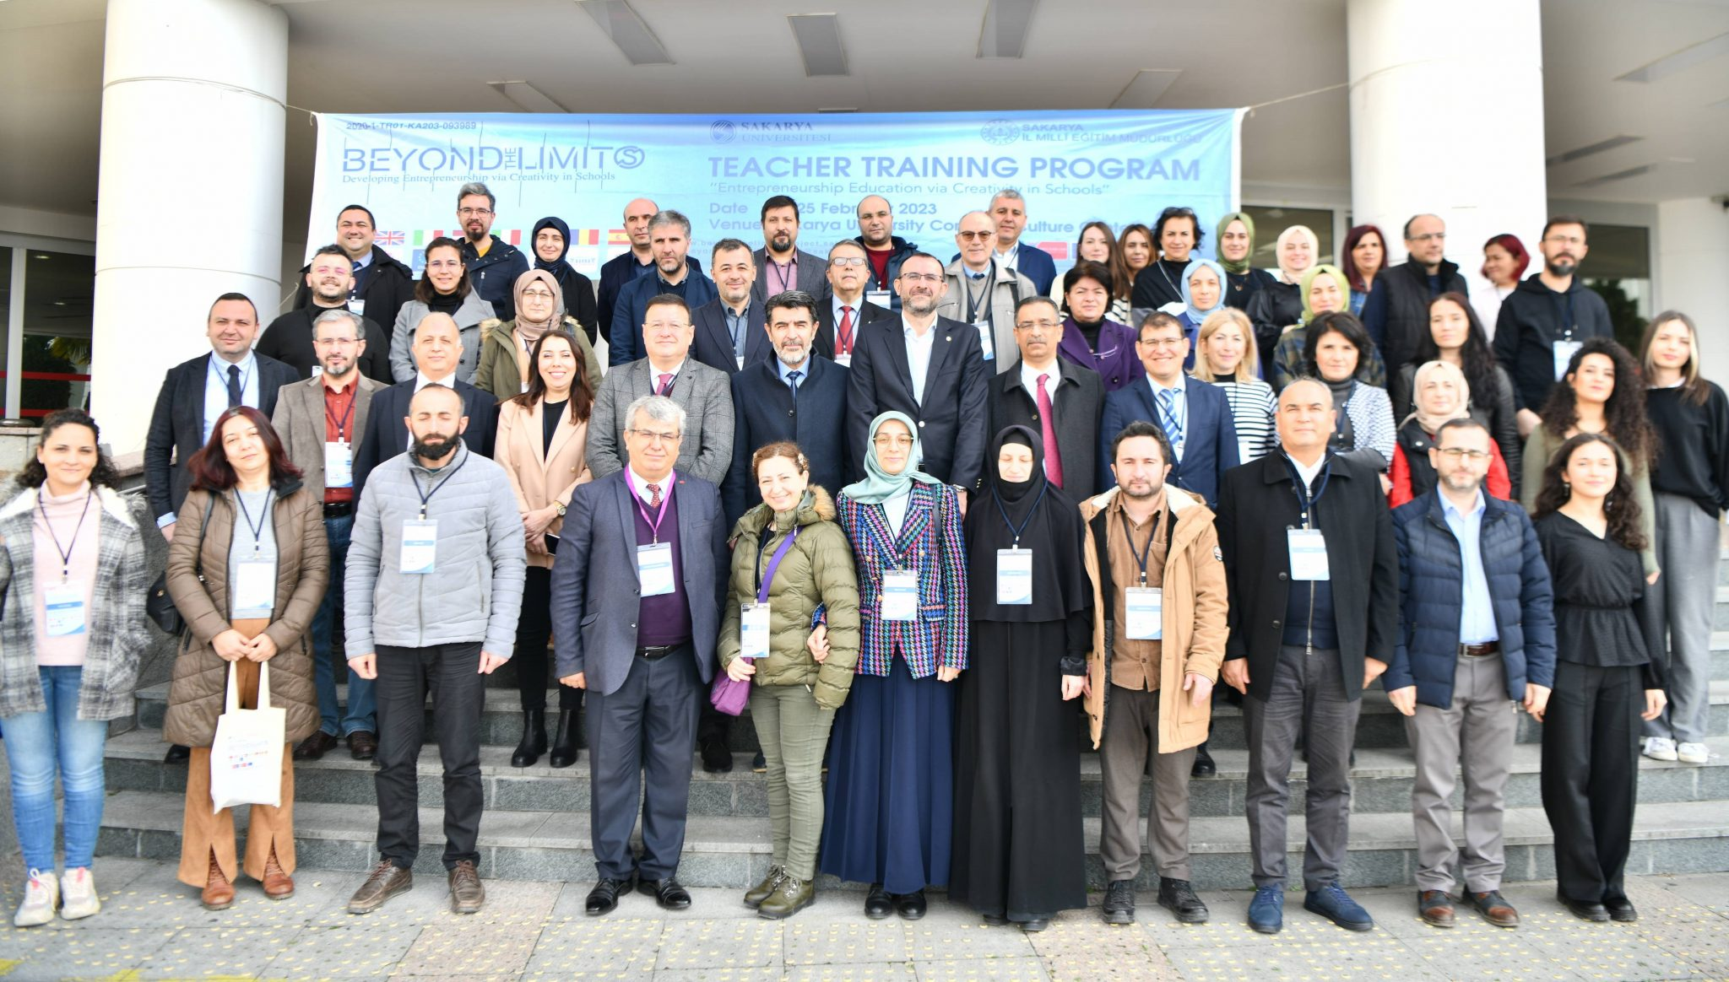Picture 5. A Group Picture with the Teacher Training Group
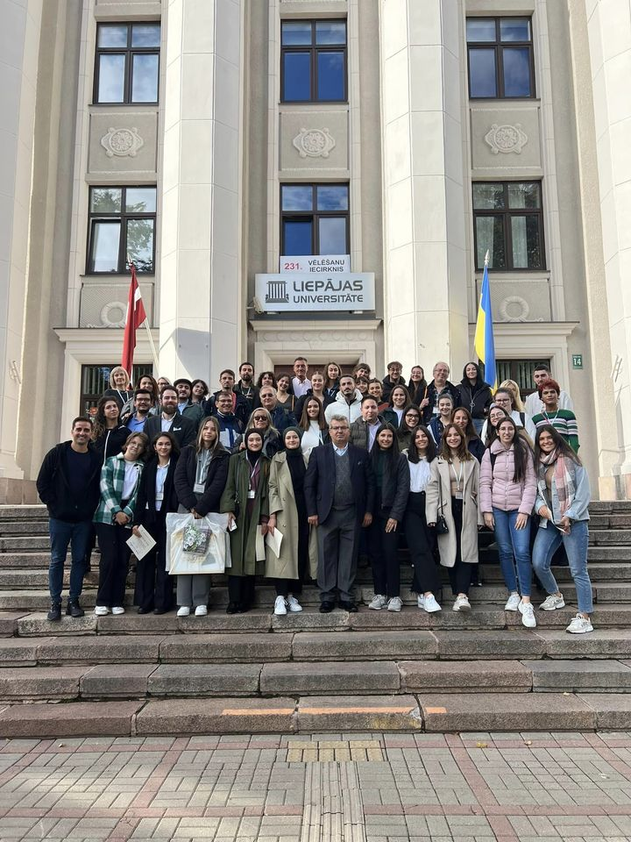
Picture 6. Students participating in the Student Training Program in front of Liepaja University
4. Curriculum Development: Within the scope of the project, under the leadership of the Italian partners, 2 14-week entrepreneurship-related syllabi were prepared based on the EU Qualifications Framework, which can be applied both at high school and university level, and the prepared syllabus was published from the Curriculum Development public menu on the link http://www.beyondthelimitsproject.sakarya.edu.tr/curriculum.html by taking the ISBN number.
5. Conference Books: As dissemination activities of the project, ICLEL 22 conferences were held on 5-7 July 2022 after the I. project meeting at the University of Granada and ICLEL 23 conferences were held on 6-8 July 2023 after the II. project meeting at the University of Coimbra, where invited speakers and participants of the dissemination activities from nearly 30 different countries made face-to-face, poster and online presentations. Approximately 165 people attended ICLEL 22 and 220 people attended ICLEL 23 face-to-face and online. The abstracts and full text of the participants' papers were published in conference books with ISBN numbers. These outputs are available at http://www.beyondthelimitsproject.sakarya.edu.tr/conference-book-2022.html and http://www.beyondthelimitsproject.sakarya.edu.tr/conference-book-2023.html.
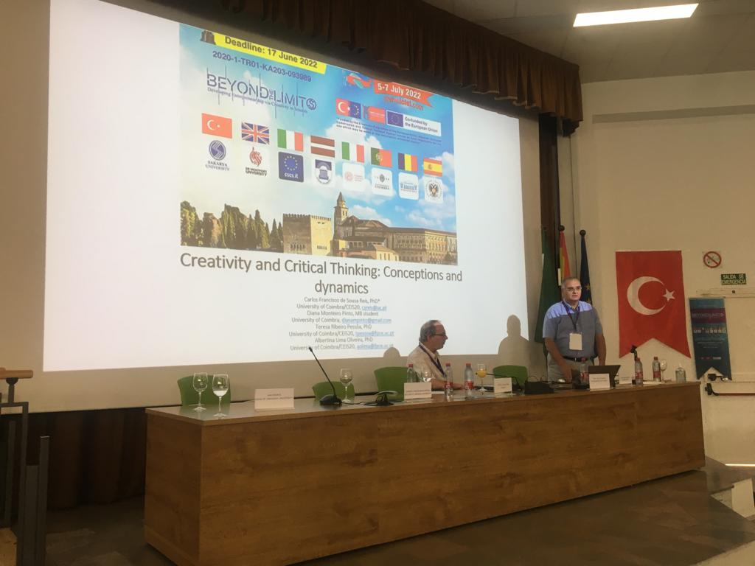Picture 7. University of Granada ICLEL 22 Dissemination Activity Invited Speakers (Prof. Dr. David RAE and Prof. Dr. Carlos Sousa REIS).
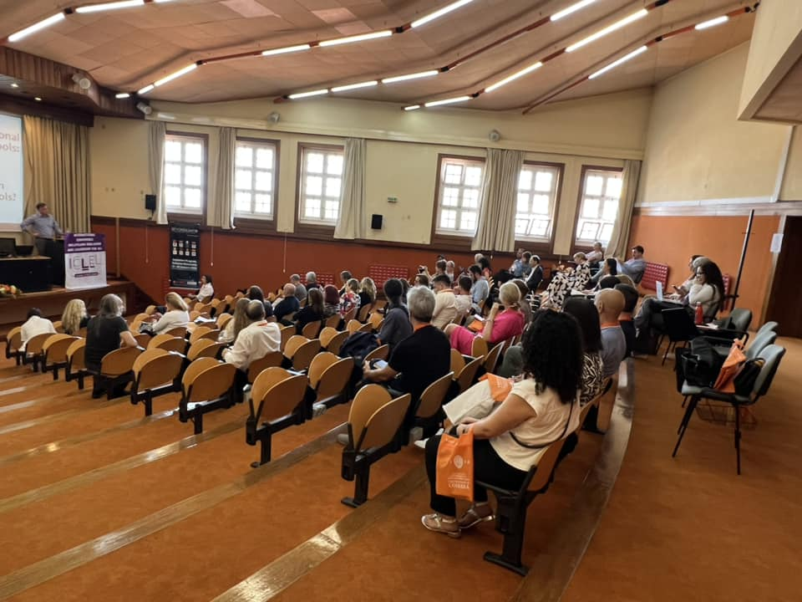Picture 8. ICLEL 23 Keynote Speaker Prof. Dr. Prof. Dr. Dana REDFORD/ USA Speaking Moment
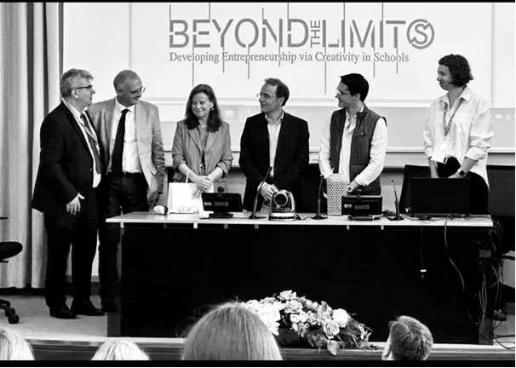Picture 9. Rector, Dean and Coordinators of the University of Coimbra at the ICLEL 23 Opening Ceremony
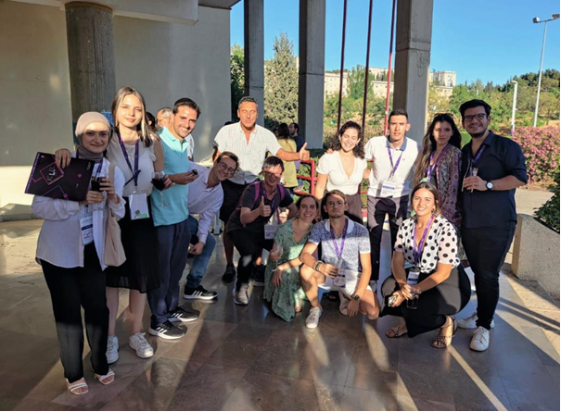Picture 10. A frame from ICLEL 22 participants
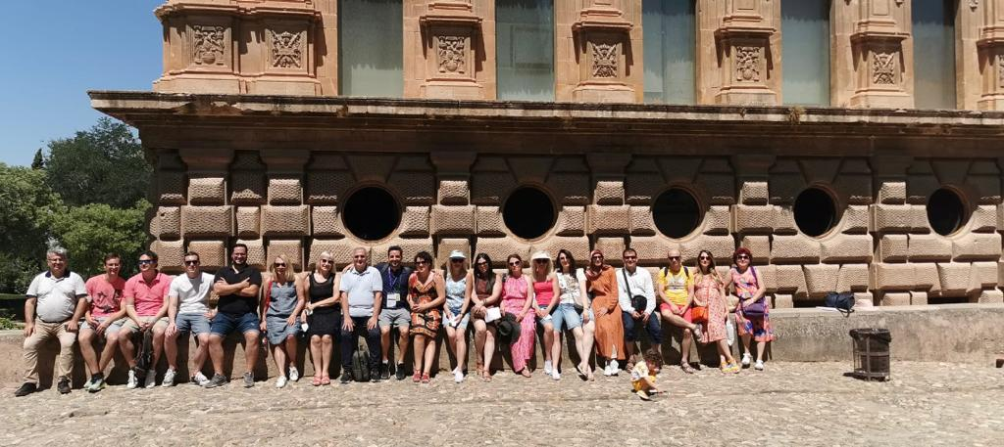Picture 11. Some of the ICLEL 22 Participants on a Cultural Tour of Al-Hambra
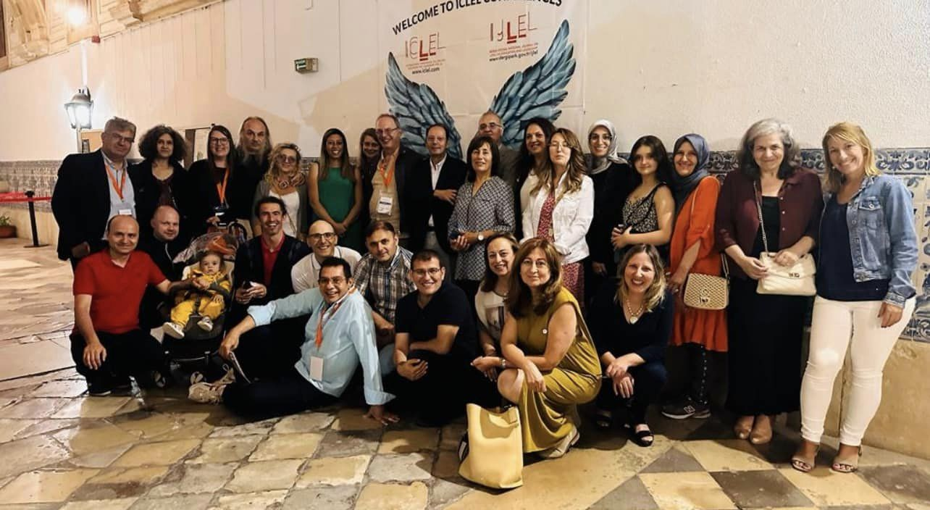Picture 12. A Frame from the Participants at ICLEL 23 at the University of Coimbra
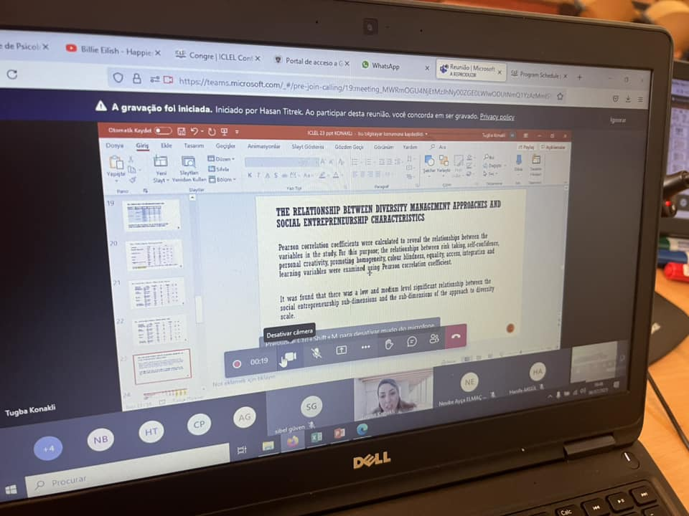Picture 13. A Frame from Virtual Presentations
In addition, the project partners have worked and continue to work to disseminate the project activities by participating in many different media and congresses and are trying to increase the level of awareness of the project.
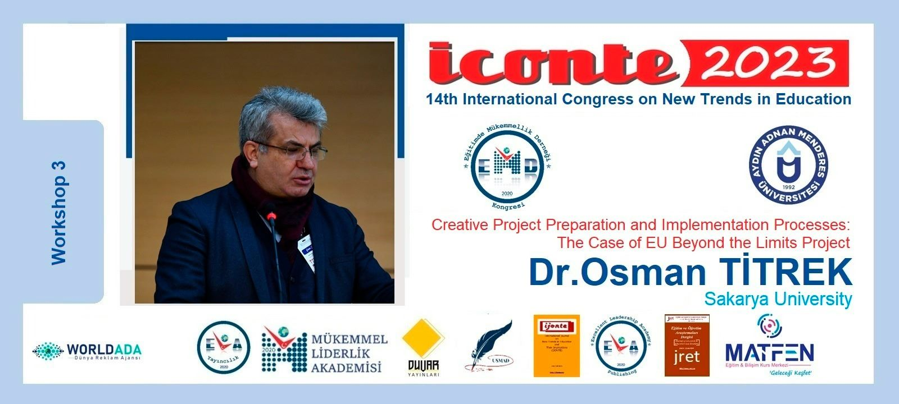
Picture 14. A Frame from BLimits Project Dissemination Activities

CONCLUSION
This EU KA203 project, which aims to increase entrepreneurial skills through creativity in education, is a team that has successfully achieved its objectives and has managed to realize its targeted project outputs with the cooperation and support of all partners despite the obstacles created by COVID 19. It can be stated that by sharing all its activities openly on the website www.beyondthelimitsproject.sakarya.edu.tr, which was prepared in the first phase, it provided resources not only to students and teachers but also to people and researchers all over the world interested in this subject and realized its vision development role in the most effective way. In addition, within the scope of this project, it can be stated that the entrepreneurship skills of students at national and international level have been analyzed and an important resource has been provided on what should be done in education to further develop and contribute to the development of a new perspective.
In this context, the project coordinator, Prof. Dr. Osman TİTREK, a faculty member of Sakarya University Faculty of Education, would like to thank the Turkish National Agency for providing financial support to the project, all university rectors, deans, faculty members and researchers who served as project partners and made efforts.

