ICLEL 2023 CONFERENCE
9th INTERNATIONAL CONFERENCE ON LIFELONG EDUCATION AND LEADERSHIP FOR ALL
UNIVERSITY OF COIMBRA- FACULTY of PSYCHOLOGY and EDUCATION SCIENCES- PORTUGAL
JULY 6-8, 2023
ICLEL 2023 CONFERENCE BOOK TIMELINE
6.7.2023 | 9:30-11:00 | Opening ceremony
 | 11:00-12:00 | Keynote Speaker: Prof. Dr. Dana Redford - President, PEEP – Policy Experimentation & Evaluation Platform / Senior Fellow, University of California, Berkeley. Keynote Speech: Entrepreneurship Education through the Creative Use of AI Tools
 | 12:00-13:30 | Parallel Sections - Conference Presentations
 | 13:30-14:15 | LUNCH
 | 14:15-16:00 | Keynote Speaker: Prof. Dr. Mirzana Pašić Kodrić, University of Sarajevo – Bosnia and Herzegovina. Keynote Speech: Questions of Otherness.  Keynote Speaker: Prof. Dr. David Rae, De Montfort University – United Kingdom.  Keynote Speech: The individual – collective construct in entrepreneurship: competing or complementary ideologies?
 | 16:00-16:30 | Coffee Break
 | 16:30-18:00 | Parallel Sections - Conference Presentations
7.7.2023 | 09:00-10:30 | Parallel Sections - Conference Presentations
 | 10:30-11:00 | Coffee break
 | 11:00-12:45 | Keynote Speaker: Prof. Dr. Dan Petrica, Agora University of Oradea – Romania. Keynote Speech: Using Artificial Intelligence (AI) to empower creativity.  Keynote Speaker: Prof. Dr. Pablo Garcia Sempere, University of Granada – Spain & Prof. Dr. Pablo Rodriquez Herero, Autonomous University of Madrid – Spain. Keynote Speech: Creating a new model for Teacher Education: Inclusive co-teaching with teachers with intellectual disabilities
 | 12:45-14:00 | LUNCH
 | 14:00-15:30 | Parallel Sections - Conference Presentations
 | 15:30-16:00 | Coffee break
 | 16:00-17:45 | Keynote Speaker: Prof. Dr. Albertina Oliveira & Prof. Dr. Prof. Dr. Carlos Sousa Reis, University of Coimbra – Portugal. Keynote Speech: Needs analyses about entrepreneurship and creativity in European countries.  Keynote Speaker: Prof. Dr. José Gijón Puerta, University of Granada – Spain. Keynote Speech: Understanding human creativity through biology, genetics, and culture.
 | 20:30-22:30 | Gala Night - Buffet & Music
8.7.2023 | 09:30-11:00 | Parallel Sections - Conference Presentations
 | 11:00-11:30 | Coffee break
 | 11:30-12:30 | Keynote Speaker: Prof. Dr. Regina Frank De Monfort university - United Kingdom. Keynote Speech: Educating for a sustainable future.
 | 14:30-17:00 | Cultural Visiting of UNESCO HERITAGE parts of University of Coimbra
 | 15:00-17:00 | Guided Visiting UNESCO Heritage (University of Coimbra)
9.7.2023 |  | Departure from Coimbra

EU Beyond the Limits: Developing Entrepreneurship via Creativity in Schools project (GRANT_NUMBER: 2020-1-TR01-KA203-093989) dissemination activity (ICLEL 23 conference / 9th INTERNATIONAL CONFERENCE ON LIFELONG EDUCATION AND LEADERSHIP FOR ALL
) was organized using Hybrid method at University of Coimbra, Faculty of Psychology and Educational Sciences- PORTUGAL between 6-8 July 2023.
At the Opening Ceremony, Prof.Dr. Amílcar Celta Falcão Ramos Ferreira (Rector of University of Coimbra) and Prof.Dr. Maria Paula Barbas Albuquerque Paixão -Dean of Faculty of Psychology and of Educational Sciences, of University of Coimbra, President of the Academic Students Association of University of Coimbra, Dr. João Caseiro, Prof.Dr. Osman Titrek-Project Coordinator and Prof.Dr Carlos Sousa de Reis-Iclel 23 Chair made their speeches. Prof.Dr. Osman Titrek presented some infos about EU Beyond the Limits project from Web site (www.beyondthelimitsproject.sakarya.edu.tr) and explained what they are doing during this project to all participants. Prof.Dr Carlos Sousa de Reis-Iclel 23 Coordinator explained the situation and activities of dissemination activity-ICLEL 23.
About 230 people participated to these activities in person and virtually during the ICLEL 23 (www.iclel.com) from 27 different countries. Opening Ceremony, oral and poster presentations, workshops and round table academic activities were organized at Faculty of Phycology and of Educational Sciences auditorium and classrooms. Face-to-face presentations were held in the classrooms of the University of Coimbra. Keynote Speeches were also organized at the Auditorium of the Faculty. Gala and Portugal Cultural Night including Fado Music were held and presented Portugal meals, desserts.
Online presentations were made through Microsoft Teams and organized by Turkish Team.
At the end of the dissemination activity, we visited main Unesco Heritage places of the University with a guided tour and we had amazing information’s about the University and Portugal history and heritage. Also we had a chance to see historical chapel, Hall of the Throne, were PhD thesis used to be presented, and also amazing Joanina Library. Some photos taken from the conference are given below. 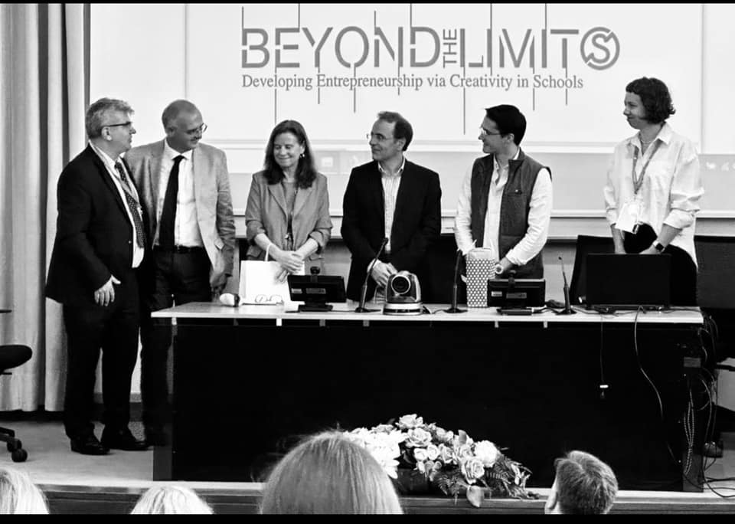
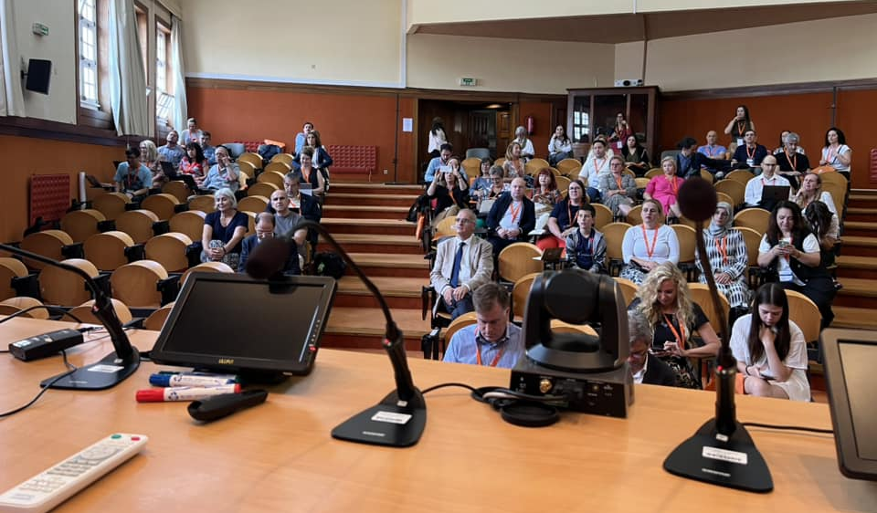

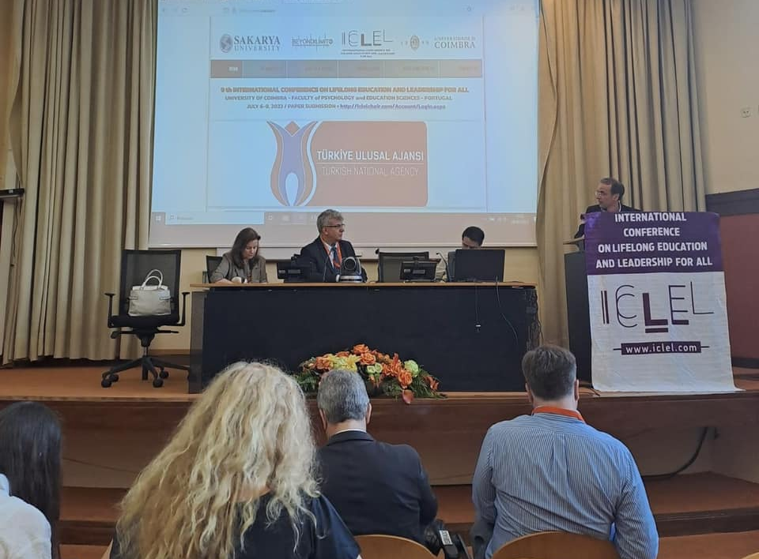

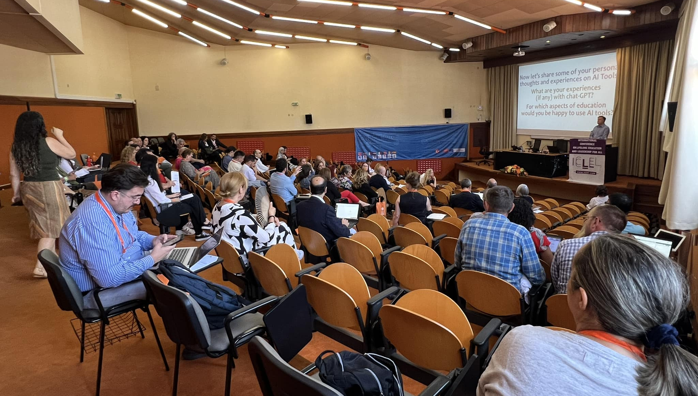

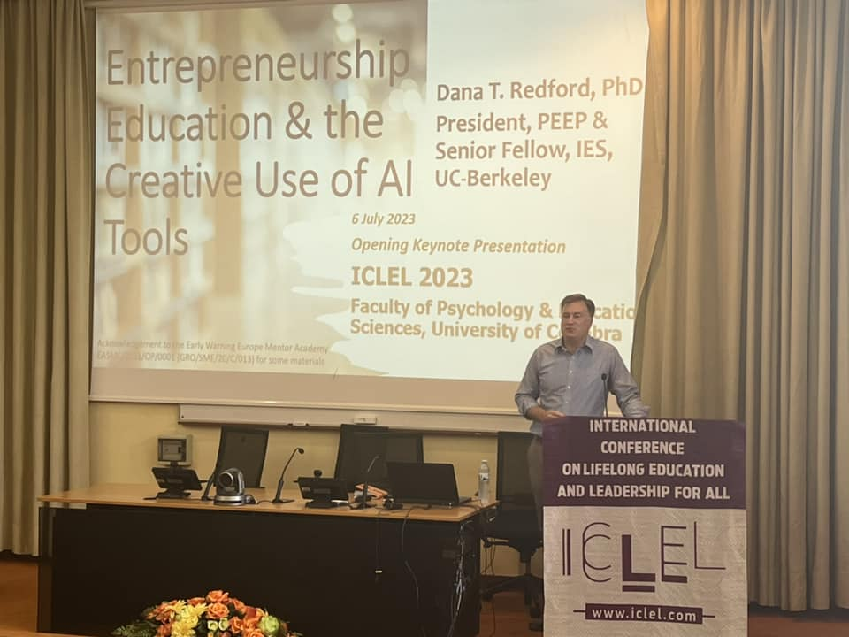

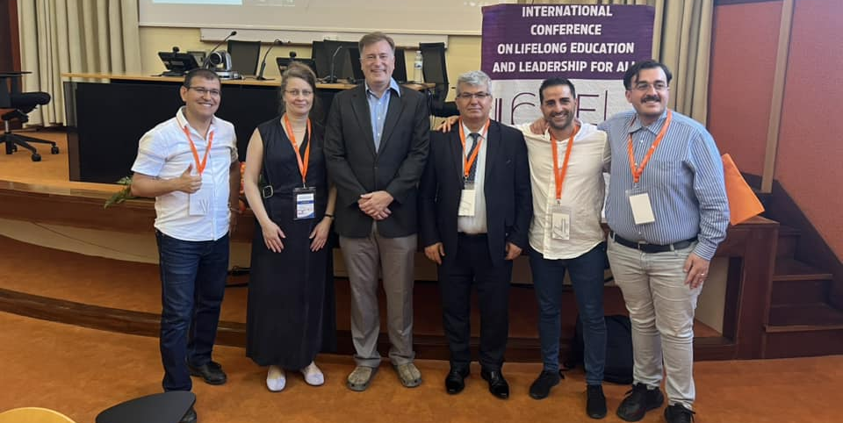

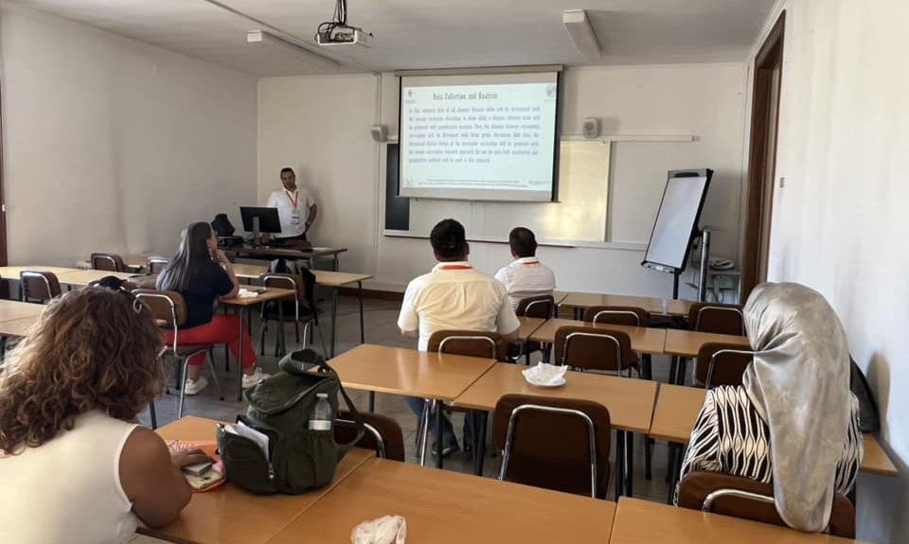

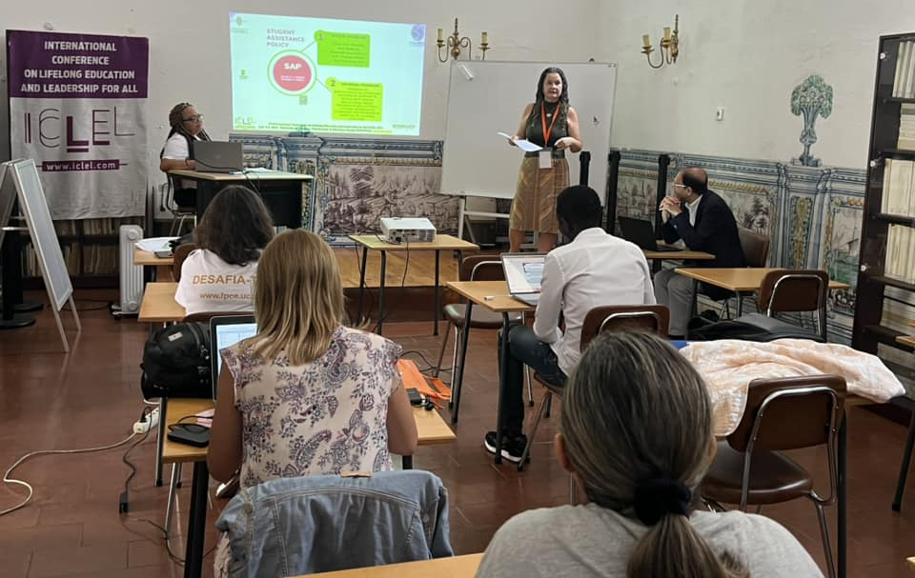

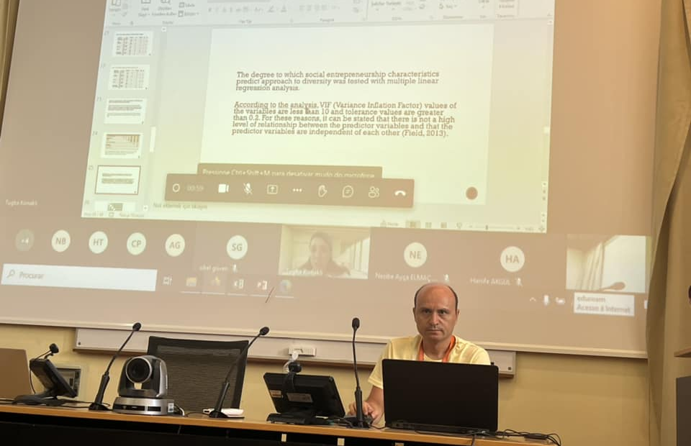

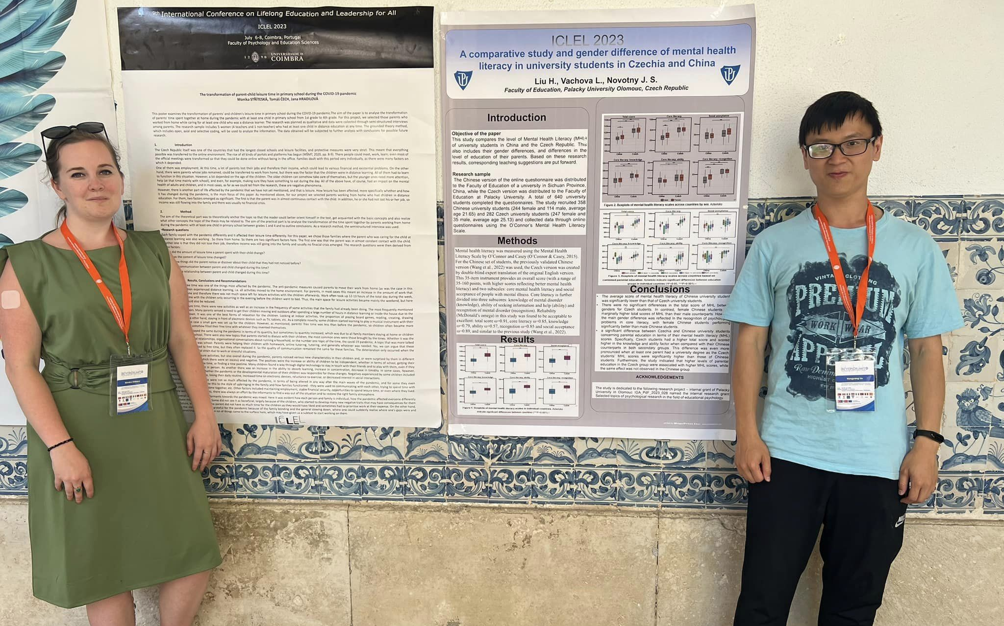

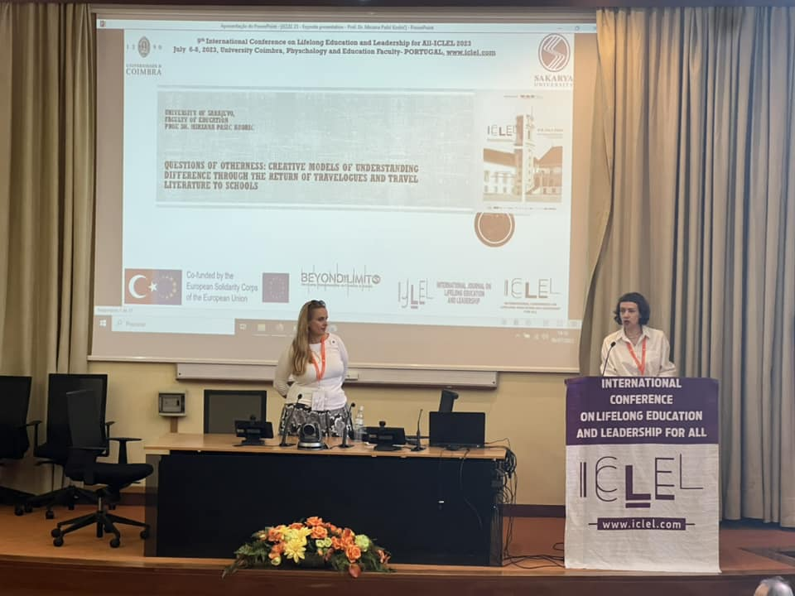
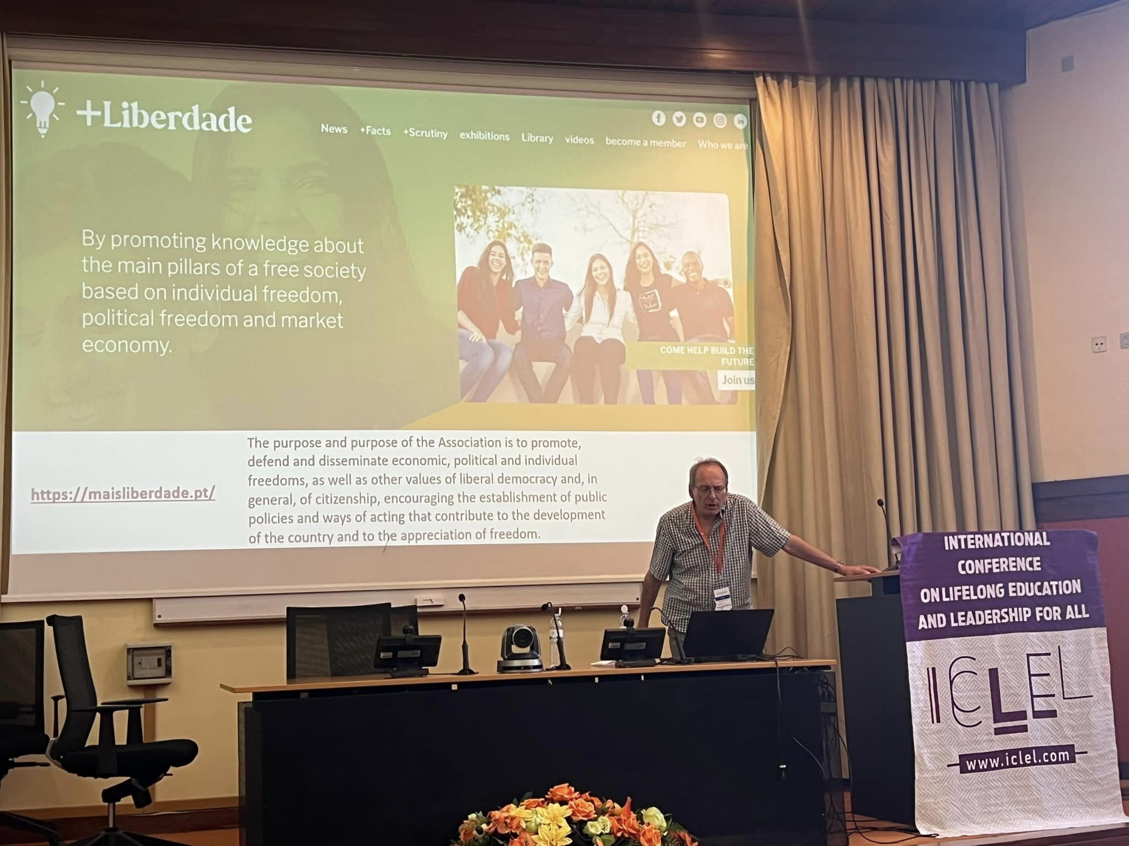

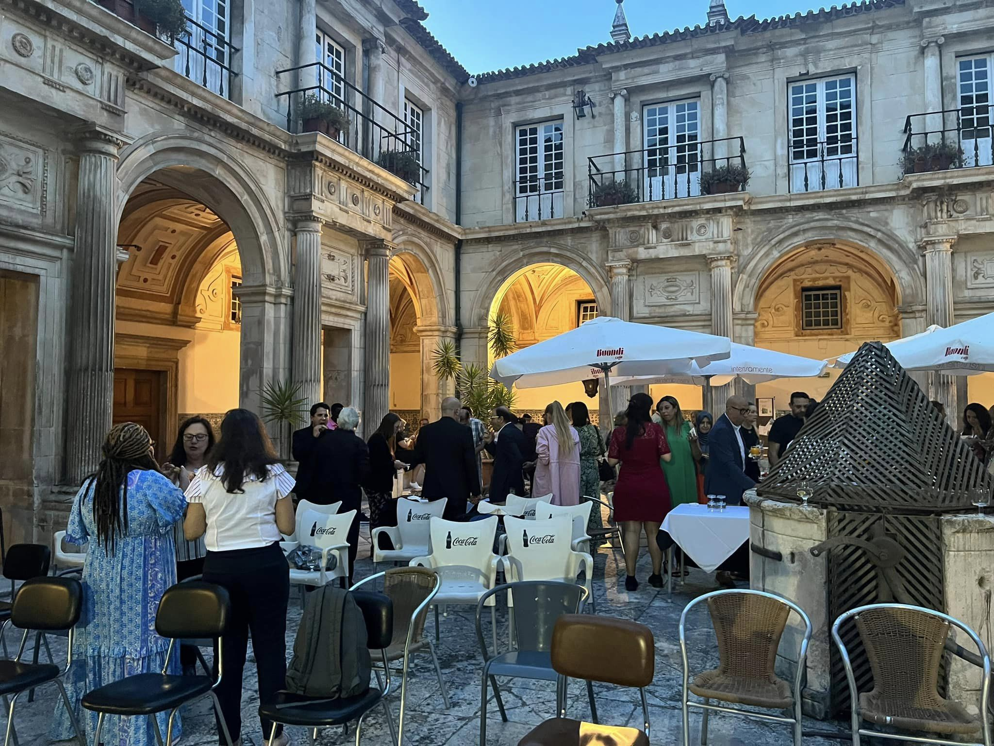
Gala 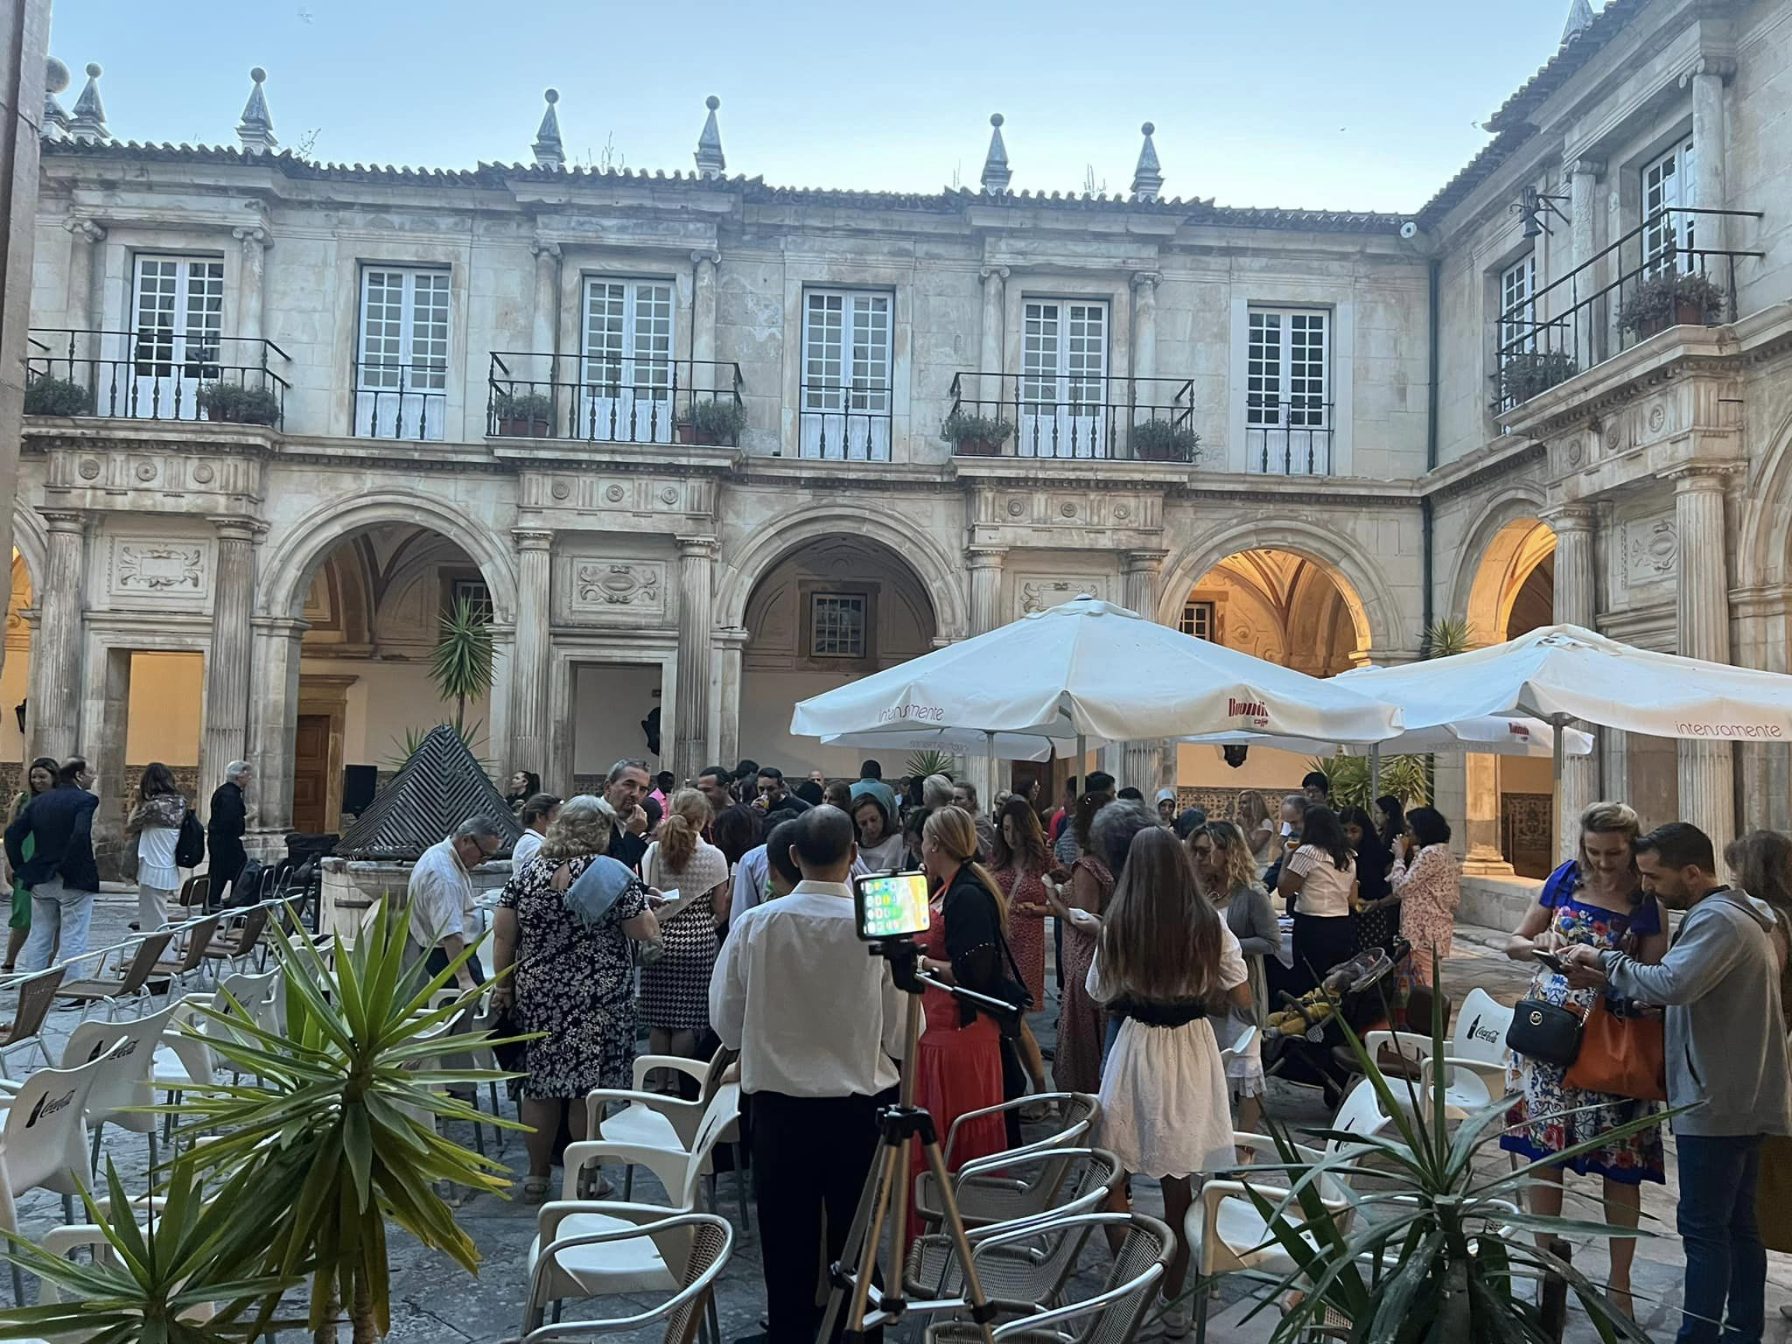

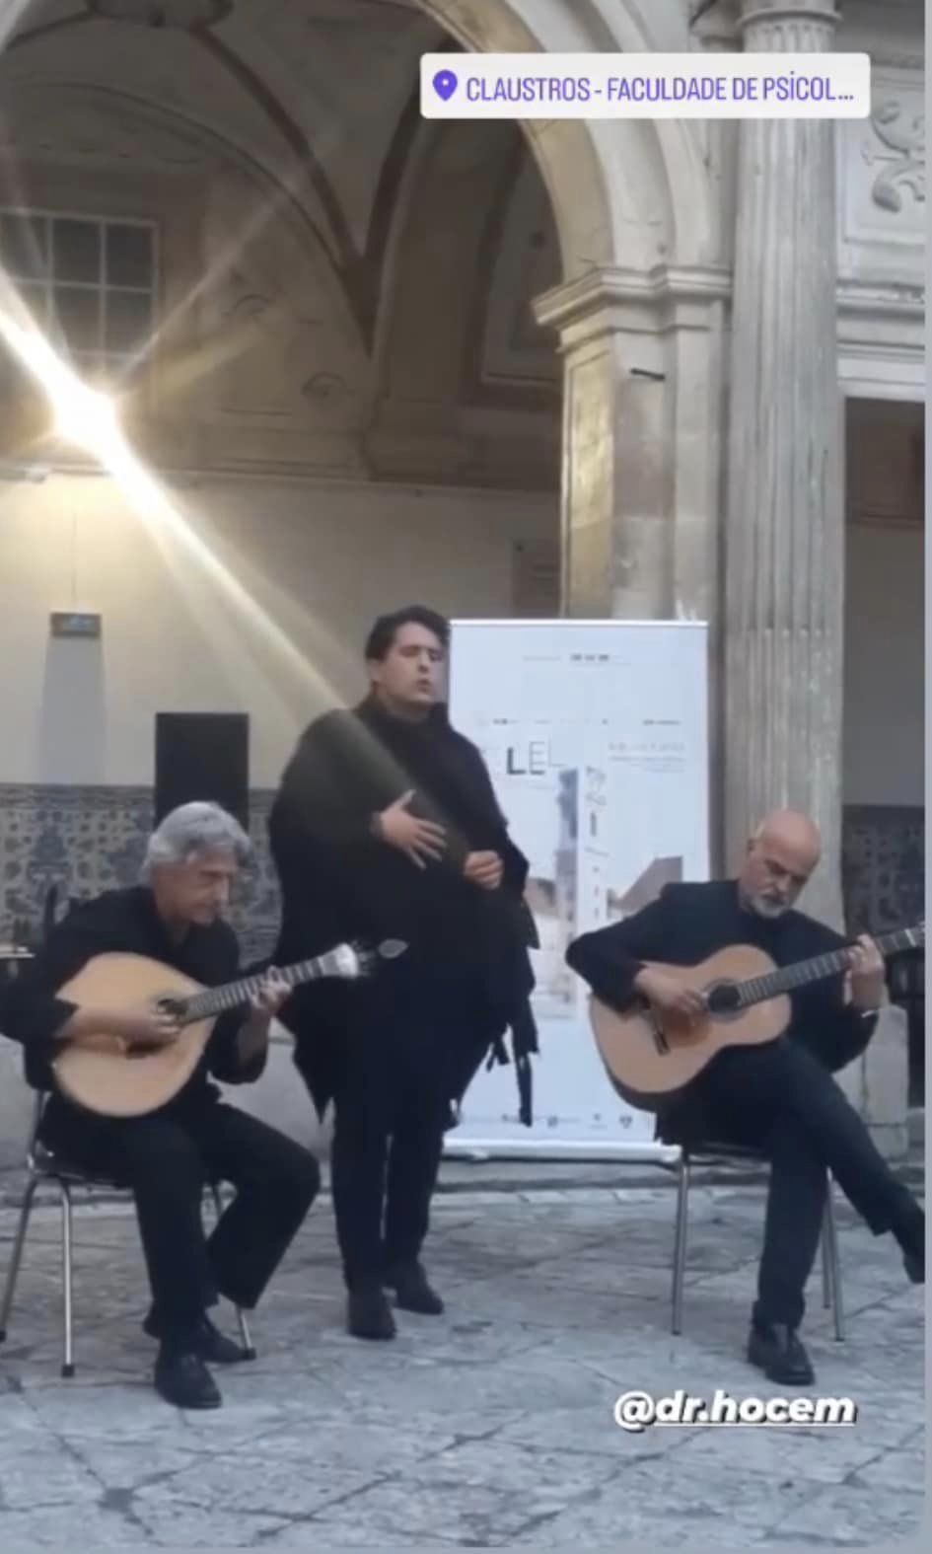

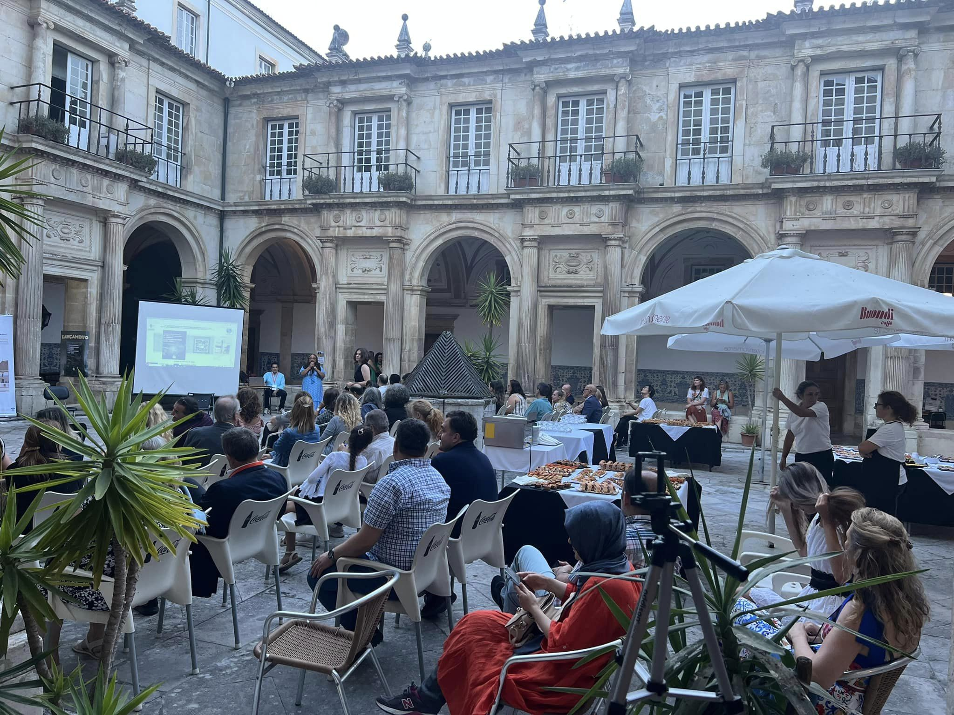

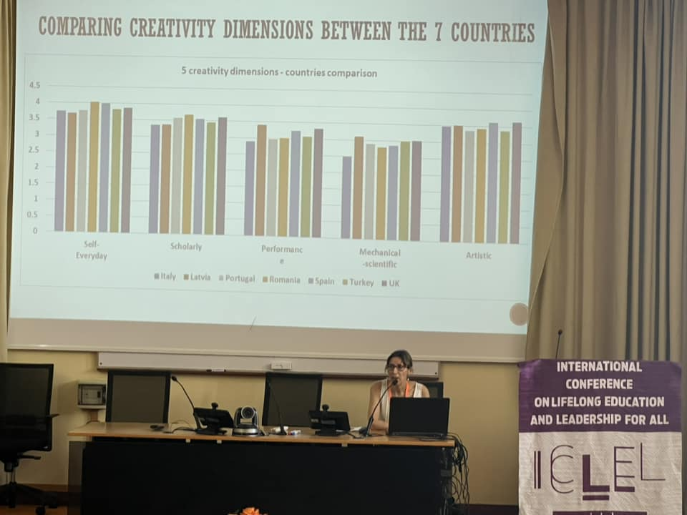
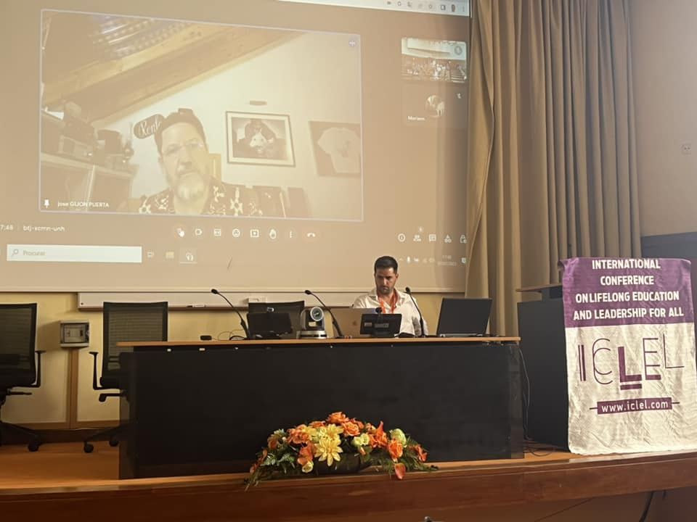

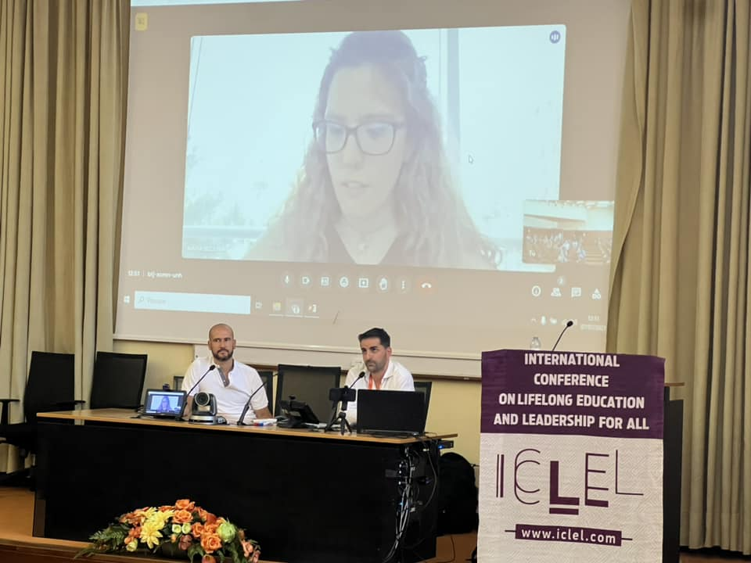
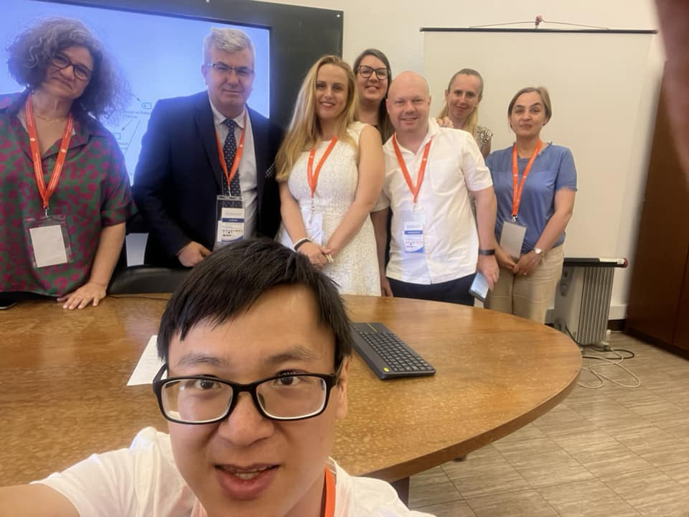

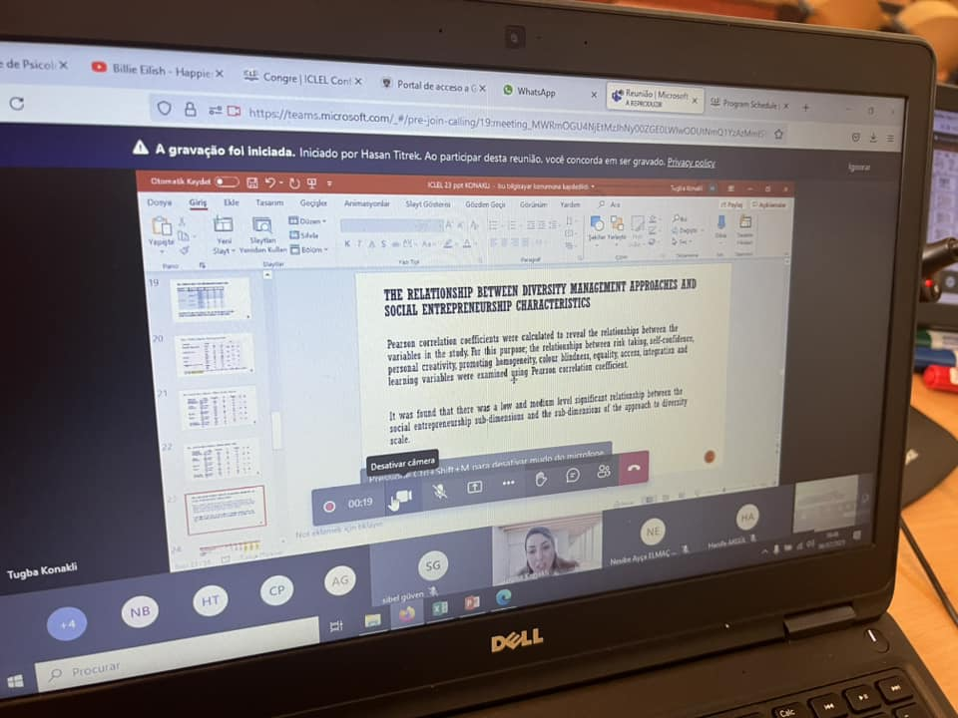

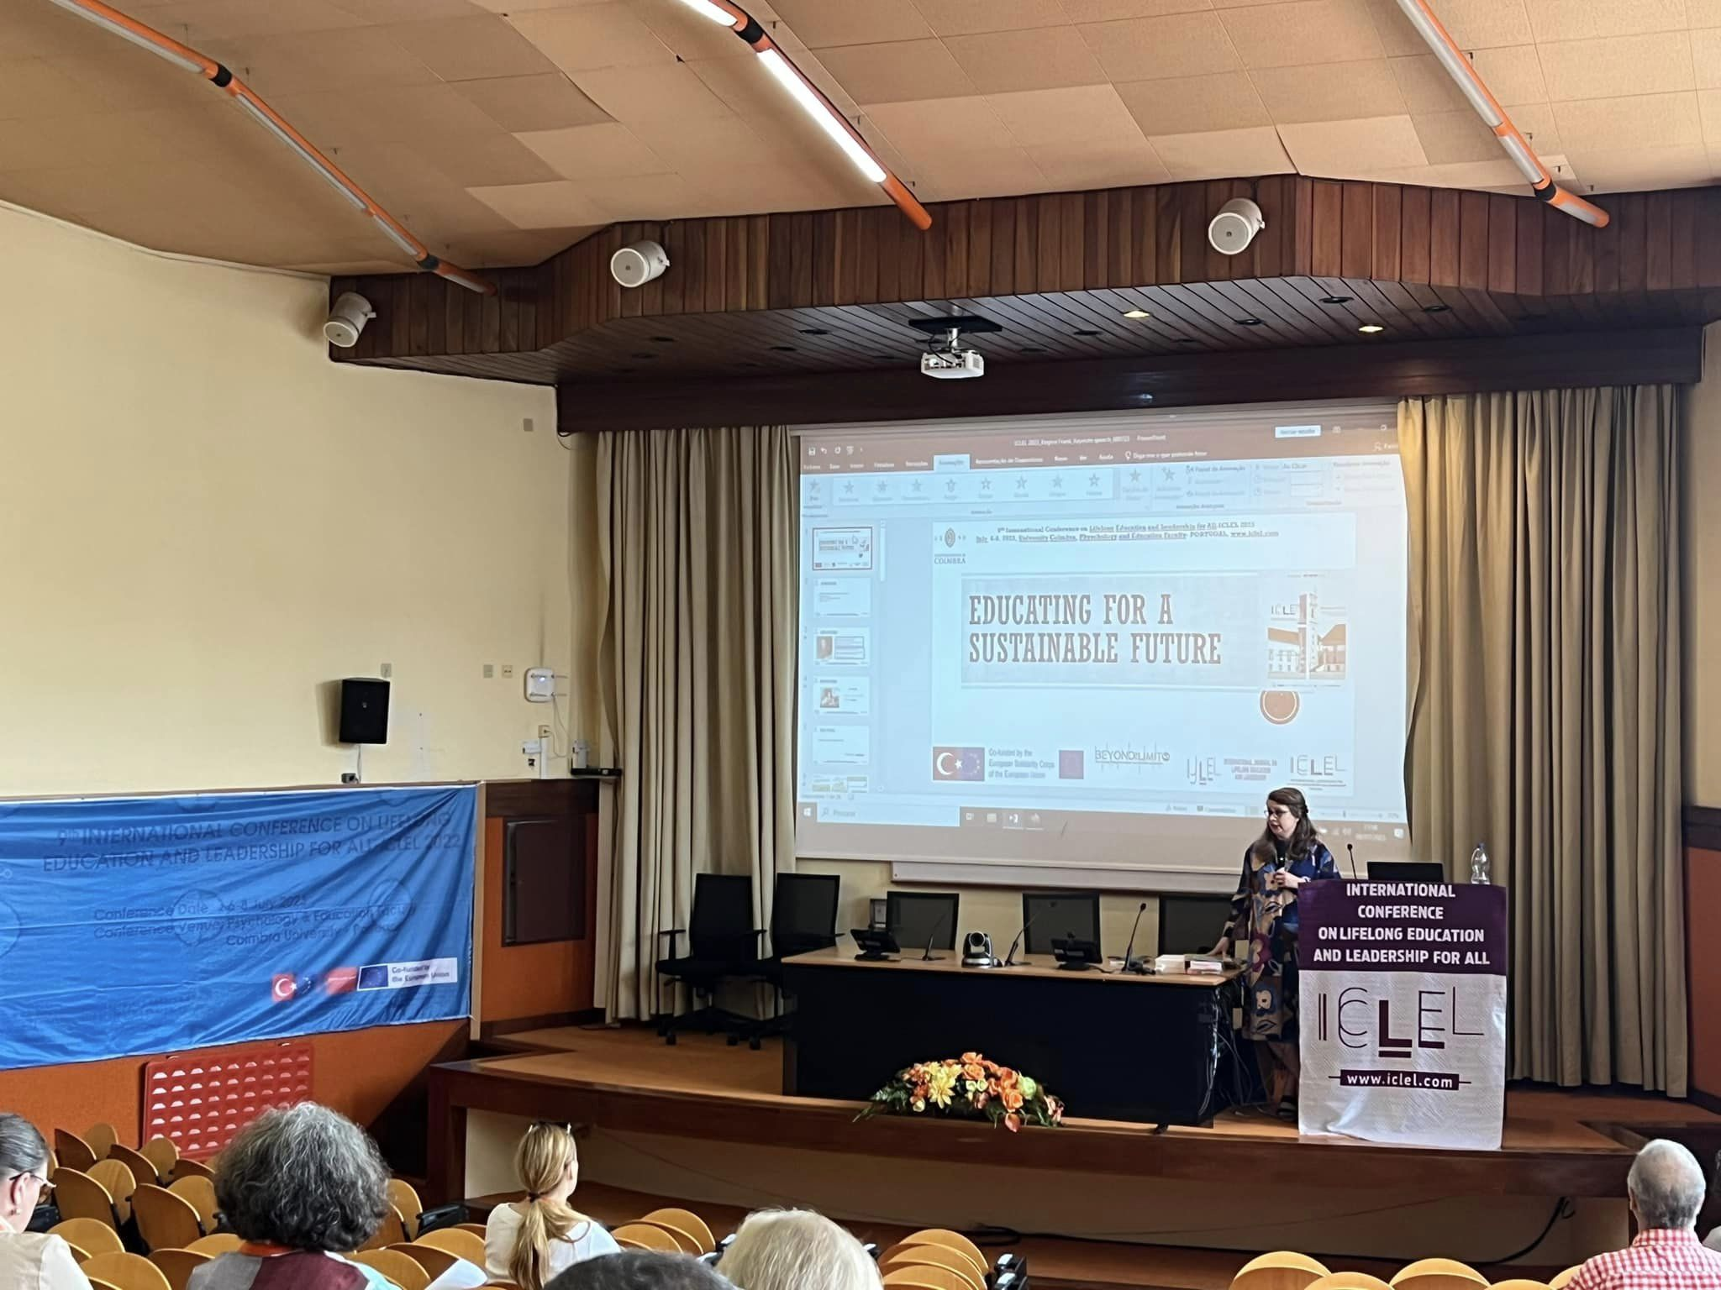

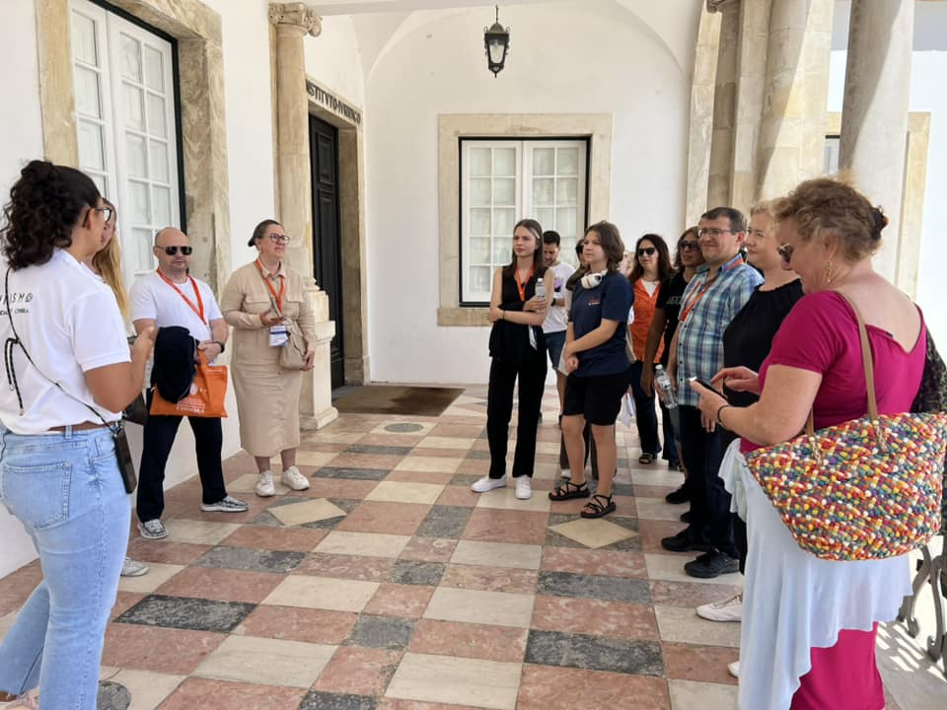

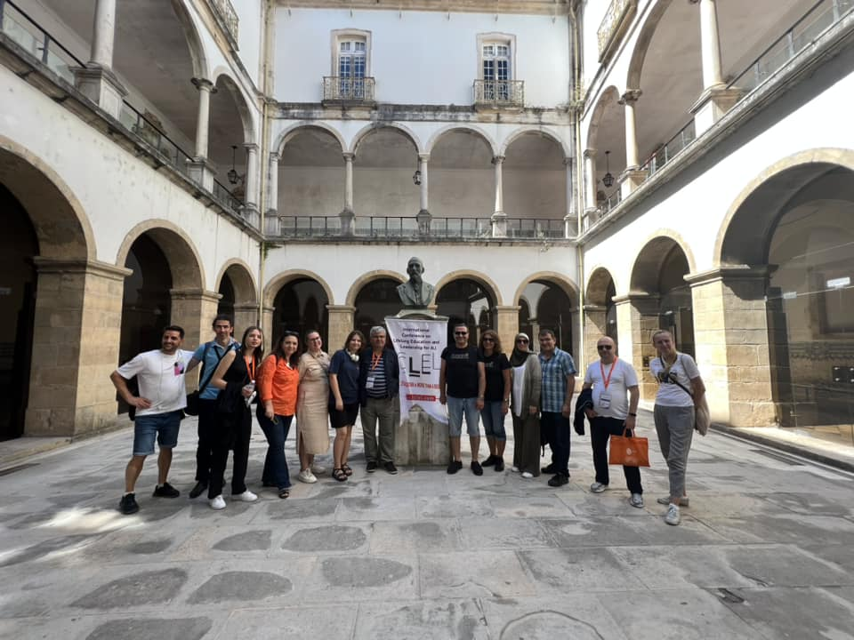

ICLEL 2023 congress was held in a proper Hybrid model (face-to-face and online) without any problems within this program. More than 200 participants from 27 countries participated in this activity face-to-face and online. Prof. Dr. Dana Redford- President, Policy Experimentation & Evaluation Platform (PEEP) Senior Fellow, Institute of European Studies, UC Berkeley from the USA; Assoc. Prof. Dr. Mirzana Pasic Kodric from the University of Sarajevo, Bosnia and Herzegovina and Prof. Dr. David Rae- De Montfort University, UK; Prof. Dr. Carlos Sousa de Reis- Coimbra University /Portugal; Prof. Dr. Jose Puen Guerta- University of Granada / Spain; Assoc. Prof. Dr. Pablo Garcia Sempere- University of Granada and Prof. Dr. Pablo Rodriquez Herero-Autonomous University of Madrid /Spain and Dr. Dan Petrica-Romania gave face-to-face speeches as a keynote speaker. Prof. Dr. Albertina Oliviera (University of Coimbra / Portugal) shared the data on the levels of entrepreneurship and creativity both in partner countries and globally based on the research on the Needs Analysis conducted within the scope of the EU Beyond the Limits project activities. Dr. Regina Frank (De Montfort University - UK) gave the closing speech of the dissemination activities. The keynotes of the project activities were broadcast live on ICLEL conferences Instagram account. In addition to workshops, round table discussions, a cultural Fado music event at the Gala Night, a tour of the famous historic Coimbra University Central Campus and a Gala Dinner and Portuguese Culture were some of the activities during the conference that were actively participated. In the last stage of the project activities, the central campus of the University of Coimbra, which has been included in the UNESO Heritage List, its halls, thesis defense hall, historical chapel and library were visited, listening to information from the guide about the history of the university and the foundation of Portugal.

Prof. Dr. Osman TİTREK, coordinator of the EU KA203 project "Beyond the Limits: Developing Entrepreneurship via Creativity in Schools" thanked the Rector of Sakarya University Prof. Dr. Hamza AL; Prof.Dr. Amílcar Celta Falcão Ramos Ferreira (Rector of University of Coimbra); Prof.Dr. Maria Paula Barbas Albuquerque Paixão -Dean of Faculty of Psychology and of Educational Sciences, of University of Coimbra, Prof. Dr. Rüştü YEŞİL, Dean of the Faculty of Education-Sakarya University; Prof. Dr. Carlos Sousa REIS and his team, the project coordinator of the University of Coimbra, and all project partners and all participants who participated in the activities in person and online, and all members of the Organizing Committee, the editorial board and the referee board and all those who contributed and participated, for their support in these difficult times and for the successful completion of the EU Beyond the Limits project activities and ICLEL 2023.
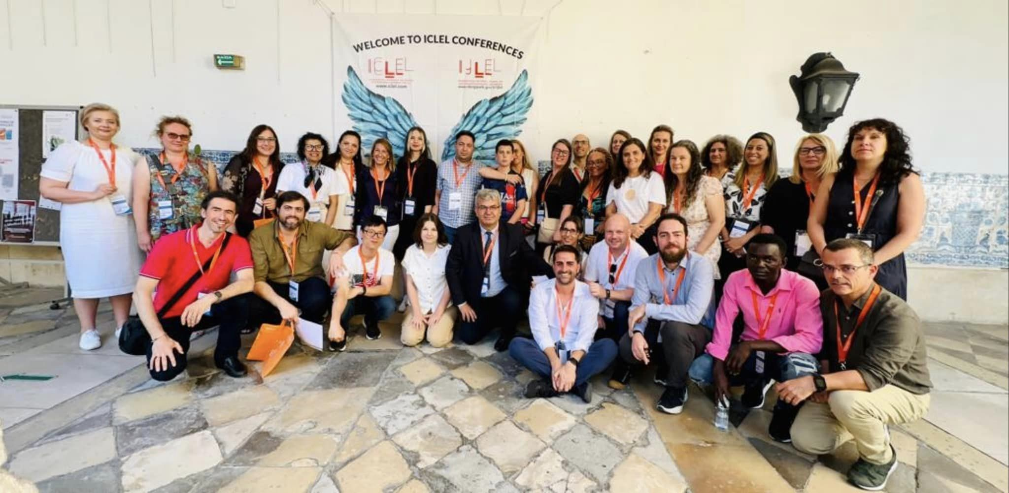

During the activities, we made dissemination from Prof.Dr. Osman Titrek facebook and youtube accounts. Keynote speeches were broadcasted as alive from iclel_conferences instagram account and also some disseminations were delivered from Beyond the Limits Twitter account. Also all partners shared via their social media accounts as well.
At the end of meeting and activities we made some disseminations from university web pages such as ;
https://haber.sakarya.edu.tr/uluslararasi-proje-coimbra-universitesinde-gerceklestirildi-h114031.html
https://www.youtube.com/watch?v=e32XdSdwnwo
https://medyabar.com/haber/15743864/uluslararasi-proje-portekizin-coimbra-universitesinde-gerceklestirildi
https://www.gozlemsakarya.com/uluslararasi-proje-coimbra-universitesi-nde-gerceklestirildi/24612/?fbclid=IwAR2AbuieppoatamXVmTcQxnQSq_0sbot749r1GsOhgTsBBe96weFhGVPbaU
https://haber.sakarya.edu.tr/uluslararasi-proje-coimbra-universitesinde-gerceklestirildi-h114031.html

Uluslararası Proje Coimbra Üniversitesi’nde Gerçekleştirildi
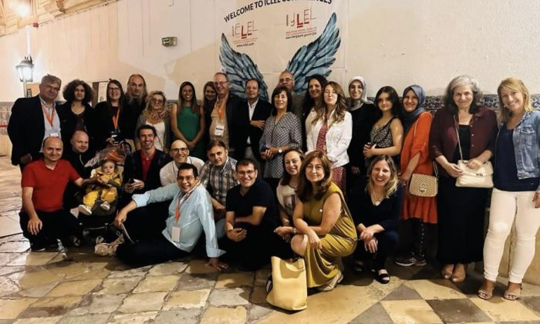
EĞİTİMETKİNLİKGÜNDEMMANŞET
14.07.2023
0
AB Beyond The Limits Ka 203 projesi ve Multiplier Event (ICLEL 2023) 3-8 Temmuz 2023 tarihleri arasında Portekiz’in Coimbra Üniversitesi Psikoloji ve Eğitim Fakültesi’nde başarıyla gerçekleştirildi.
Koordinatörlüğünü Sakarya Üniversitesi (SAÜ) Eğitim Fakültesi Öğretim Üyesi Prof. Dr. Osman Titrek’in yaptığı, 7 ortaklı AB Ka 203 projesi olan “Beyond the Limits: Developing Entrepreneurship via Creativity in Schools projesi Ulus Ötesi Proje Toplantıları ve 2’nci Yaygınlaştırma Faaliyeti-Multiplier Event (ICLEL 2023) etkinlikleri 3-8 Temmuz 2023 tarihleri arasında Portekiz’in Coimbra Üniversitesi’nde gerçekleştirildi.
3-5 Temmuz 2023 tarihlerindeki Uluslararası Proje Toplantıları’nda, proje işleyişi, ihtiyaç analizi uygulaması, e-book yayınlanması süreci ve en son toplantıda da program geliştirme çalışmaları ile ilgili çıktıların durumları ve daha etkili uygulama seçenekleri tartışıldı. Yine bu hafta içerisinde projenin yaygınlaştırma etkinliği (Multiplier Event) olan ICLEL 2023 konferansları da Hibrid metodu ile başarı ile ortakların işbirliğinde düzenlendi.
Bu faaliyete de yaklaşık 27 ülkeden 200 ün üzerinde katılımcı yüzyüze ve online olarak katılım sağlamıştır. ABD, den Prof. Dr. Dana Redford- President, Policy Experimentation & Evaluation Platform (PEEP) Senior Fellow, Institute of European Studies, UC Berkeley, Bosna- Hersek’ten Saraybosna Üniversitesi Öğretim Üyesi Doç. Dr. Mirzana Pasic Kodric ve yine ortaklardan Prof. Dr. David Rae- De Montfort Üniversitesi /İngiltere, Prof.Dr. Carlos Sousa de Reis- Coimbra Üniversitesi /Portekiz, Prof. Dr. Jose Puen Guerta- Granada Üniversitesi/ İspanya, Doç. Dr. Pablo Garcia Sempere- Granada Üniversitesi ve Prof Dr Pablo Rodriquez Herero-Autonomous University of Madrid /İspanya ve Dr. Dan Petrica- Romanya da yüzyüze çağrılı konuşmalarını gerçekleştirmiştir. Yine Prof. Dr. Albertina Oliviera (Coimbra Üniversitesi /Portekiz) ise AB Beyond the Limits proje faaliyetleri ve özellikle de ihtiyaç analizi ile ilgili yapılan araştırmalara dayalı olarak hem ortak ülkelerde hem de global girişimcilik ve yaratıcılık düzeyleri ile ilgili verileri tüm katılımcılarla çağrılı konuşması ile paylaştı. Dr. Regina Frank (De Montfort Üniversitesi-İngiltere) yaygınlaştırma faaliyetlerinin kapanış konuşmasını yaptı.
Ayrıca workshoplar, round table tartışmalarının yanısıra, Gala Gecesinde Portekiz kültürel Fado müzik etkinliği ve Gala Yemeği ile Portekiz yemek kültürü de aktif katılımcılar tarafından öğrenildi. Proje etkinliklerinin son aşamasında ise, Coimbra Üniversitesi’nin Uneso Heritage Listesi’ne alınan merkez kampüsü, salonları, tez savunma salonu, tarihi şapeli ve kütüphanesi gezilerek, üniversitenin ve Portekiz’in kuruluş tarihi hakkında bilgiler verildi.
Ekim 2023 ün sonunda tamamlanması planlanan AB KA203 projesi olan “Beyond the Limits: Developing Entrepreneurship via Creativity in Schools” projesinin koordinatörü Prof. Dr. Osman Titrek, AB Beyond the Limits proje faaliyetlerinin ve yaygınlaştırma faaliyeti olan ICLEL 2023’nin başarı ile sonlandırılması ve katkılarından dolayı başta Sakarya Üniversitesi Rektörü Prof. Dr. Hamza Al’a, Coimbra Üniversitesi Rektörü Prof. Dr. Amilcar Celta Falcao Ramos Ferreira’ya, Eğitim Fakültesi Dekanı Prof. Dr. Rüştü Yeşil’e, ve Coimbra Üniversitesi Psikoloji ve Eğitim Fakültesi Dekanı Prof. Dr. Maria Paula Palxao’ya, proje faaliyetlerinde ağırlayan Coimbra Üniversitesi proje koordinatörü Prof. Dr. Carlos Sousa Reis ve ekibine ve tüm proje ortaklarına ve faaliyetlerine yüz yüze ve çevrimiçi olarak katılan tüm katılımcılara, Türk ekibinden Prof. Dr. Mustafa Bayrakcı, Doç. Dr. Ömer Faruk Vural, Doç. Dr. Gözde Sezen Gültekin’e ve Organizasyon Komitesi’nin tüm üyeleri, editörler kurulu ve hakem kurulu ve emeği geçenlere ve katılımcılara teşekkürlerini iletti.

University of Agora Oredea-Romanian Team Dissemination

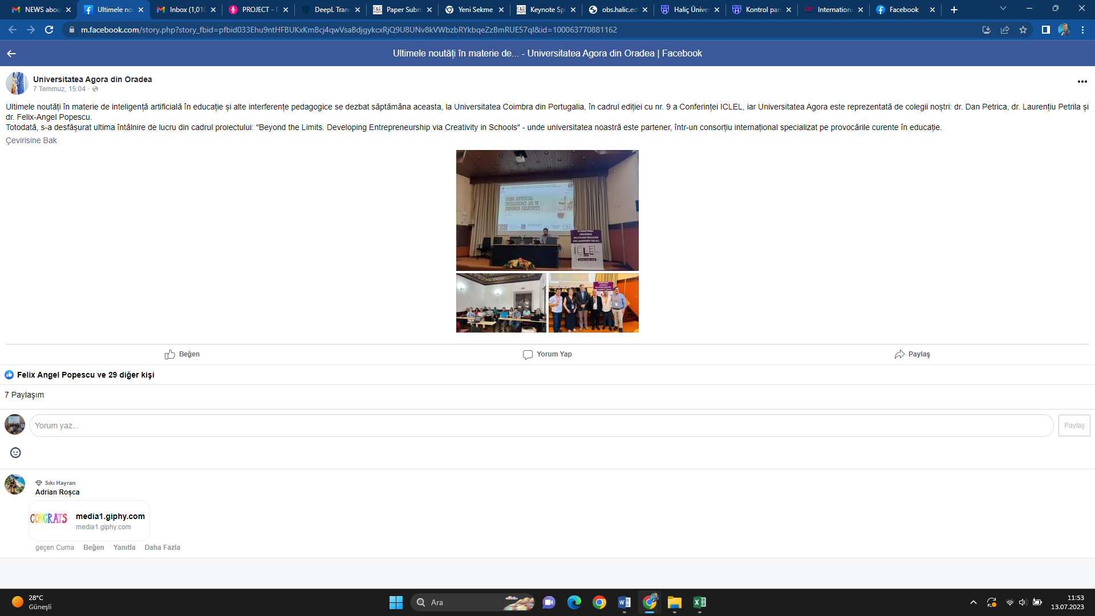

University of Coimbra Dissemination News
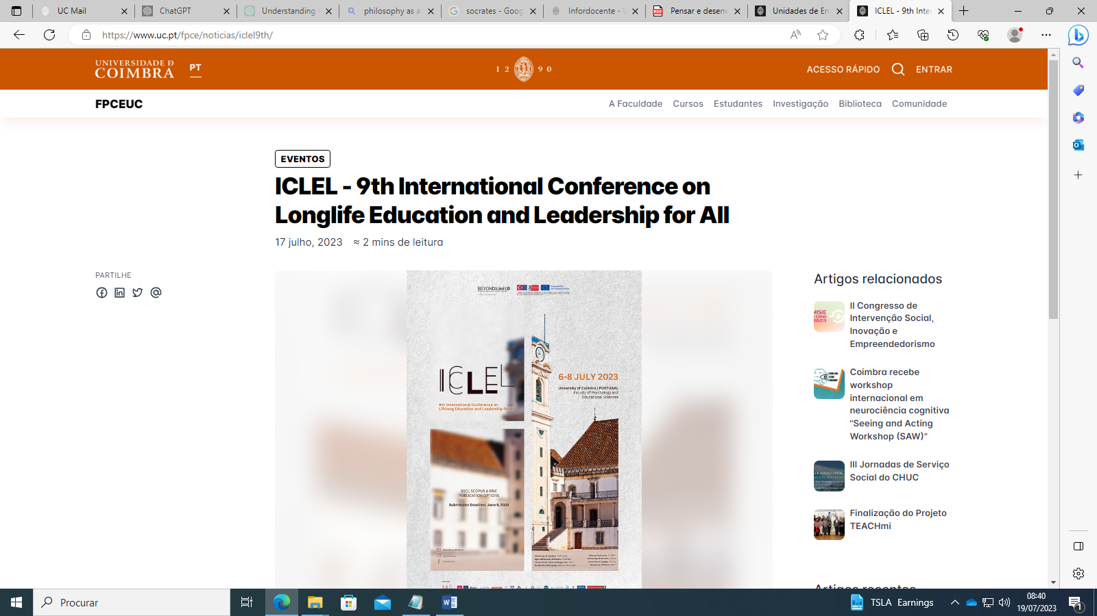

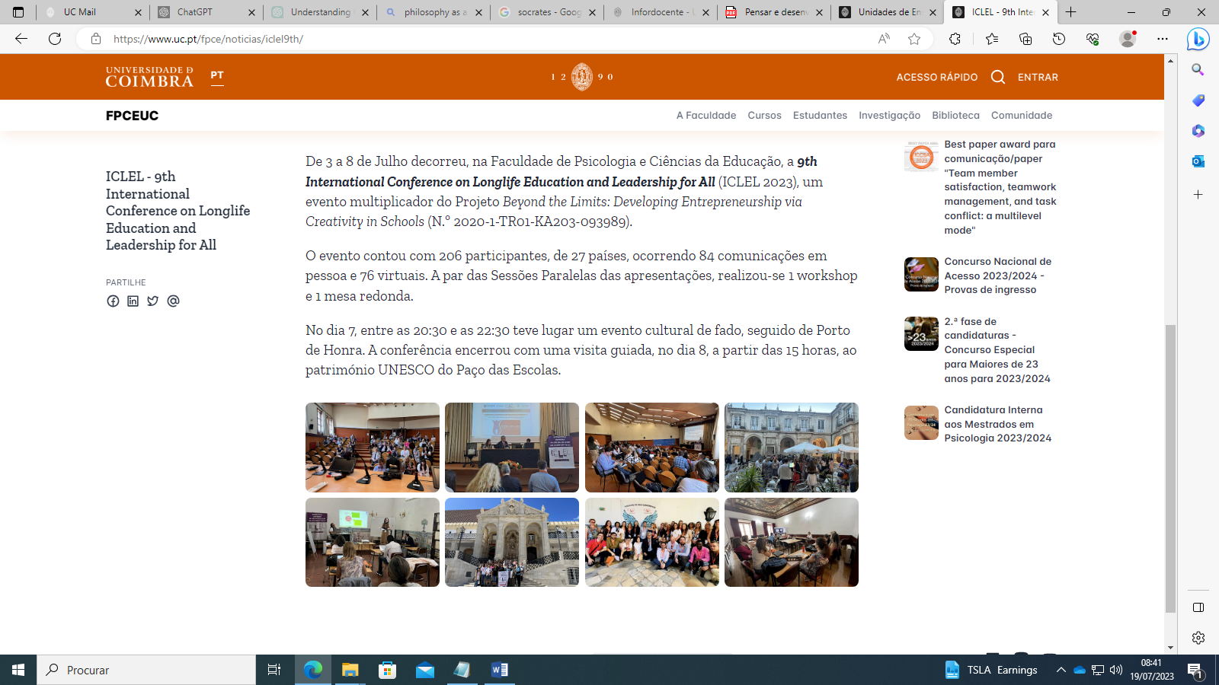
https://www.instagram.com/p/Cu6f8QkvImo/
https://www.instagram.com/p/CvCRJRtNJPX/
https://www.instagram.com/p/CubZcJSoMM_/
https://www.instagram.com/p/CuZVqZrB0gi/
https://www.instagram.com/p/CuZN_EcBmUq/
https://www.instagram.com/p/CuWfzMpoc7x/
https://www.instagram.com/p/CuaMIm3B0MB/
https://www.facebook.com/osman.titrek.3/
https://twitter.com/beyondt29077346

